**Design and Development of Prognosis based Body Monitoring and reporting System using Time Series Analysis**

**M.Tech. Dissertation in**

**Department of Computer Science and Networking**

**Submitted By : Prashaanth R M**

**Reg. No. : 18ETCS037001**

**Supervisors : Jishmi Jos Choondal**

**August – 2020**

**FACULTY OF ENGINEERING AND TECHNOLOGY**

**M. S. Ramaiah University of applied sciences**

**Bengaluru -560 054**

**FACULTY OF ENGINEERING AND TECHNOLOGY**



# *Certificate*

*This is to certify that the Dissertation titled* ***“Design and Development of Body Monitoring and Reporting System using Time Series analysis”*** *is a bonafide record of the work carried out by Mr. Prashaanth R M, Reg. No. 18ETCS037001 in partial fulfilment of requirements for the award of M. Tech. Degree of M. S. Ramaiah University of Applied Sciences in the Department of Computer Science and Engineering.*

**August – 2020**

**Asst. Prof. Jishmi Jos Choondal**

Supervisor

**Prof. Raghavendra Kulkarni Prof. H. K. Narahari**   
Head–Dept. of CSE Dean-FET

Declaration

**Design and Development of Body Monitoring and Reporting system using Time Series Analysis**

The dissertation is submitted in partial fulfilment of academic requirements for the M.Tech. Degree of M. S. Ramaiah University of Applied Sciences in the Department of Computer Science and Engineering. This dissertation is a result of my own investigation. All sections of the text and results, which have been obtained from other sources, are fully referenced. I understand that cheating and plagiarism constitute a breach of University regulations, hence this dissertation has been passed through plagiarism check and the report has been submitted to the supervisor.

**Signature :**

**Name of the Student : Mr. Prashaanth R M**

**Reg. No. : 18ETCS037001**

**Date :**

# Acknowledgements

I intend to convey my sincere thanks to my project supervisor Prof. Jishmi Jos Choondal, Asst. Professor, Computer Science and Engineering Department for  
suggesting the dissertation topic and mentoring me throughout the project work.

I would like to thank Dr. R. V. Kulkarni, Head of Computer Science and Engineering Department who has supported through the project with his knowledge and valuable inputs.

I am very obliged to Dr. S. R. Shankarpal, Vice Chancellor, Dr. Govind. R. Kadambi, Pro Vice Chancellor and Dr. H. k. Narahari, Dean whose emphasis for quality work helped me keep my focus on my project work and complete it.

I would like to further sincerely thank the manager of M. S. Ramaiah University of Applied Sciences for providing an excellent environment throughout my studies.

Finally, I want to express my honest regards to my beloved parents for their blessings, my family and my fellow classmates for helping me and for their kind wishes for the accomplishment of this project.

Prashaanth R M

18ETCS037001

# Abstract

In today’s world, Health is major concern for every human beings on the planet. Because of delay in treatment many of the humans died. Now it is possible because of science and technology to identify and take correct actions for any disease. In most of the cases, if considering health problems are connected with and due to problems in heart. In this time, there are many gadgets available for the improvement of health system with the help of technology. But those gadgets are only for monitoring the data of body.

Body diagnosis is the process of identifying a condition, disease, disorder or problem by systematic analysis of the background history with the current evaluated test result. Effective prognosis is not possible without effective diagnosis. To increase the level of health consciousness in any person with providing some comfort this thesis work proposed with one system. The system is able to collect the data of person’s heart rate and from that it will predict the value for prognosis and send the notification through email.

In this thesis based on designed system, it will measure the heart rate and forward the value for further calculations in simulated model in LabVIEW software. Analysis is performed on the data fetched through NodeMCU board connected with pulse sensor, by using ARMA model for time series prediction analysis. System compares the value with threshold set value and decides the actual prediction for the given input to that. The predicted value and notification for any change in functionality of heart sent over the SMTP protocol to the registered Email account. Because of the designed system it is possible to predict and notify the person before criticality to be reached.

# Table of Contents

*Certificate* II

Declaration III

Acknowledgements IV

Abstract V

Table of Contents VI

List of figures XII

List of tables XV

1. Introduction 16

1.1 Introduction 16

1.2 Motivation 17

1.3 Organization of thesis 17

2. Literature Review 19

2.1 Background theory 19

2.1.1 Data mining 19

2.1.2 Data mining modelling and Methods based on classification: 20

2.1.2.1 Support vector machine (SVM): 20

2.1.2.2 Neural Networks (NN): 20

2.1.2.3 Decision Trees: 21

2.1.2.4 Gaussian Mixture Models: 22

2.1.2.5 Hidden Markov Models: 22

2.1.2.6 Rule-Based Methods: 23

2.1.3 Data mining modeling and technique based on the clustering: 23

2.1.3.1 K-means: 23

2.1.3.2 K-medoids: 23

2.1.3.3 EM clustering: 24

2.1.3.4 Outlier detection algorithm 24

2.1.4 Prognosis based techniques 24

2.1.4.1 Model based prognostics: 25

2.1.4.2 Experience/Probability based prognostics: 26

2.1.4.3 Evolutionary models for prognostics: 26

2.1.5 Internet of Things (IoT) 26

2.1.6 Biomedical application based sensor 28

2.1.7 Body monitoring systems: 30

2.1.7.1 Patient monitoring systems to ensure security 30

2.1.7.2 Health monitoring using WSN: 30

2.1.7.3 Patient monitoring with the help of mobile phones: 30

2.1.7.4 Patient monitoring using Bluetooth enabled device: 31

2.1.7.5 Health Monitoring Using Body Sensors: 31

2.1.8 Wireless Technology: 31

2.1.8.1 Wireless Fidelity (Wi-Fi): 31

2.1.8.2 WIMAX: 32

2.1.8.3 Bluetooth Technology: 32

2.1.8.4 GSM technology: 33

2.1.8.5 ZigBee: 34

2.1.9 Time Series Analysis Model: 34

2.1.9.1 Linear regression: 34

2.1.9.2 Smoothing in time series analysis: 34

2.1.9.3 Autoregressive (AR) model: 34

2.1.9.4 Moving Average models: 35

2.1.9.5 Autoregressive integrated moving average (ARIMA) model: 35

2.1.9.6 ARCH/GARCH models: 36

2.2 Literature Review 37

2.2.1 Overview of Papers and Journals Referred 37

2.2.2 Literature Summary 46

2.3 Problem Formulation 55

2.3.1 Identification of Research Gaps 55

2.3.2 Research questions the dissertation would like to address 55

3. Problem Statement 56

3.1 Title 56

3.2 Aim 56

3.3 Project Objectives 56

3.4 Methods and Methodology 57

4. Design and Implementation 59

4.1 Requirement analysis 59

4.1.1 Functional Requirements 59

4.1.2 Non-functional Requirements 60

4.2 System Specifications 60

4.2.1 Hardware requirements 60

4.2.1.1 Embedded boards 60

4.2.1.2 Sensors 64

4.2.1.3 IoT module: 65

4.2.1.4 Laptop 67

4.2.2 Software requirements 68

4.2.2.1 Arduino IDE: 69

4.2.2.2 LabVIEW: 69

4.2.3 Selected System components and Development costing 71

4.3 Design Specification 72

4.4 System Design 73

4.4.1 Block diagram of system 73

4.4.2 Schematic Diagram 75

4.4.3 Flow chart of system 75

4.5 Implementation of System 77

4.5.1 Hardware Setup: 78

4.5.2 Software Setup: 78

4.5.2.1 Simulation set up of NodeMCU and Arduino IDE: 79

4.5.2.2 Simulation Set-up in LabVIEW: 84

4.5.3 System Implementation and Design in LabVIEW 87

4.5.3.1 Implementation between NodeMCU and Arduino IDE 87

4.5.3.2 Design in Labview Using TSA ARMA Modeling and Prediction: 93

4.5.3.3 Graphical User Interface in LabVIEW: 97

4.5.3.4 Design in LabVIEW for SMTP protocol: 98

4.5.3.5 GUI design in LabVIEW for SMTP Protocol: 99

4.5.3.6 Communication between Raspberry Pi and Cloud: 100

4.6 System Integration: 101

5. Results and Discussions 102

5.1 Unit Testing 102

5.2 Integration Testing 106

5.3 System level Testing 107

5.4 Result Analysis 109

6. Conclusions and Future Directions 114

6.1 Summary of Work 114

6.2 Conclusion 114

6.3 Future Work 115

References 1

# List of figures

**Figure 2. 1** **Basic process of DM technique** 19

**Figure 2. 2** **Prognosis based techniques comparison** 24

**Figure 2. 3** **IoT in Healthcare** 27

**Figure 4. 1** **Raspberry Pi 3 model B+** 63

**Figure 4. 2** **Pulse sensor** 65

**Figure 4. 3** **Pinout Diagram of NodeMCU V0.9** 67

**Figure 4. 4** **Arduino IDE software** 69

**Figure 4. 5** **LabVIEW software** 70

**Figure 4. 6** **High level Block diagram for system** 73

**Figure 4. 7** **low level Block diagram for system** 74

**Figure 4. 8** **schematic Diagram of the System** 75

**Figure 4. 9** **Flow chart of the System** 76

**Figure 4. 10** **Hardware setup of System developed** 78

**Figure 4. 11** **Installing IDE** 79

**Figure 4. 12** **Preference Dialog box** 80

**Figure 4. 13** **Preference Dialog box for URL Path** 81

**Figure 4. 14** **Board manager Dialog** 82

**Figure 4. 15** **Determining COM port** 83

**Figure 4. 16** **configuring COM port Speed** 83

**Figure 4. 17** **Upload the code** 84

**Figure 4. 18** **Create Project** 85

**Figure 4. 19** **Create a new VI** 86

**Figure 4. 20**  **Front panel window for Create project** 86

**Figure 4. 21** **Block Diagram Window for Create new Project** 87

**Figure 4. 22** **Initialization of library** 88

**Figure 4. 23** **Print the Wi-Fi is connected** 89

**Figure 4. 24** **Set password and SSID for Wi-Fi connection** 89

**Figure 4. 25** **Set Thing speak channel KEY** 90

**Figure 4. 26** **Pulse Sensor Code** 90

**Figure 4. 27** **Fetch Pulse Value** 91

**Figure 4. 28** **SET Counter value** 91

**Figure 4. 29** **calculate Heart rate** 92

**Figure 4. 30** **ARMA Modelling and Prediction in LabVIEW** 93

**Figure 4. 31** **Graphical User Interface for ARMA Modeling and Prediction** 97

**Figure 4. 32** **SMTP Protocol Design** 98

**Figure 4. 33** **SMTP Protocol design** 98

**Figure 4. 34** **GUI Protocol for SMTP Protocol** 99

**Figure 4. 35** **Python code for fetch data from cloud** 100

**Figure 4. 36** **System setup after Integration** 101

**Figure 5. 1** **pulse sensor Testing** 103

**Figure 5. 2** **NodeMCU V0.9 Testing** 103

**Figure 5. 4** **SMTP Protocol Testing** 104

**Figure 5. 3** **Raspberry Pi Testing** 104

**Figure 5. 5** **Results of Predicted Series** 108

**Figure 5. 6** **Pulse sensor Reading** 109

**Figure 5. 7** **Raspberry Pi convert Data file into Text file** 110

**Figure 5. 8** **Sensor Data send to cloud** 110

**Figure 5. 10** **GET Criticality Notification through E-mail** 111

**Figure 5. 9** **Get E-mail with Predicted Value and message for Criticality of disease** 111

**Figure 5. 11** **Prediction Accuracy Difference between EXCEL and LabVIEW** 112

# List of tables

**Table 2. 1**  **Biomedical Sensor and its application** 28

**Table 2. 2**  **Technical properties of GSM** 33

**Table 2. 3**  **Literature summary for referred papers** 46

**Table 3. 1** **Methods and Methodology to achieve defined objectives** 57

**Table 4. 1** **Embedded boards comparison** 60

**Table 4. 2**  **IoT Module boards comparison** 64

**Table 4. 3**  **Software available for simulation design** 67

**Table 4. 4**  **Selected system components and total costing for development** 70

**Table 4. 5** **Functional blocks and its working** 92

**Table 5. 1**  **Unit testing for hardware** 103

**Table 5. 2** **Integration Testing** 106

**Table 5. 3** **System level testing** 107

# 1. Introduction

## 1.1 Introduction

## The current generation is being filled with Embedded systems. Starting from your Television, mobile phones, washing machine etc all are an embedded system. The concept of Embedded system was formed in 1965 because of the making a Computer there is where everything started. These systems have reduced two things one is manual work and another is the time taken for completion. Slowly when comparing the old computer and the new one which is used now there are a lot more differences like size, features, speed etc. This major drift has been carrying out speed all over the years. Speed is being achieved using powerful hardware and optimized and well-written firmware.

## This has been possible because of the improvement from single-core to multi-core processors in the architecture of the hardware systems. Not only that even mobile phones are like a mini computer today which is achieved using Octo-core processors. Major drift in speed is majorly concentrated since due to fast life people do not have that much time for wasting in opening different application in a computer or a mobile phone or it may be any Embedded device. To a greater extent improvisation on hardware has made software to upgrade parallelly. Strictly bringing in many features to the system has brought in many interrupt that is being solved using multithreaded programming.

Multithreaded programming contains two or more threads that are running concurrently and always looking for a time-saving notion. An interrupt will react like a process and a corresponding scheduler will be assigned to perform it. This gave birth to real-time applications which are time deterministic and the system should complete the corresponding task within the specified given time. Real-time application is being used in Automotive, aerospace, military, gaming, Server creation, space shuttle etc. When the real-time application came up it was challenging to achieve the time deterministic nature using a general-purpose operating system so, for this, a Real-time operating system was required. The first operating system was launched way back when Apollo 11 shuttle was made and it was the AGC computer weighed in at 30 kg, ran at 1MHz and only had 74Kb of ROM and 4Kb of RAM but now we have many RTOS like Xenomai, VxWorks, FreeRTOS, OSEK, QNX, LynxOS etc.

There are many differences between RTOS and GPOS right from their scheduling, priority, threads, memory utilization etc. General purpose operating systems cannot perform real time tasks whereas RTOS is suitable for real time applications. ... Latency is a problem with GPOS but it is overcome using real time OS. Priority inversion cannot be done in GPOS, it is done with real time kernel. Different programming languages have different capabilities and there are many languages like C, Java, C++, python etc that has multithreading capabilities and the real-time capabilities are added in different ways in each programming language. The real-time application developed using different languages like C and Java will behave in a different way which will be analyzed here.

## 1.2 Motivation

Embedded system has a wide range of study. Every day we come across hundreds to thousands Embedded system. The current generation that is followed in Embedded systems is being filled with different real-time applications it may be hard, soft or firm real-time applications. Thanks to technology that has brought different methods in achieving real-time capabilities. Real-time applications are very time-critical and deadline-driven which are achieved using real-time threads. Multithreaded programming drives the RTA in and out that in turn motivates the user to use that particular application.

Many languages have multithreading support but there are very few languages which are being used in the market for developing. So, the C(POSIX threads) and JAVA(Java threads) language will be taken as the first preference and their real-time capabilities will be studied by developing a real-time application. Different Static and Dynamic analysis will be made to test their capabilities. Based on these kinds of analysis not developed yet it can be easy to examine the POSIX and java threads capabilities in developing a real-time application.

## 1.3 Organization of thesis

The dissertation has six chapters which include an introduction to the topic, background theory and literature survey, problem statement, design and implementation, results and discussion and conclusion.

# 2. Literature Review

The chapter comprises of three topics, background theory and the overview of the papers, literature gaps identified and the summary of the papers referred. Technical papers and documents which are relevant to the topic are considered and reviewed.

## 2.1 Background theory

## 2.2 Literature Review

This section explicates the journals and technical papers referred briefly and it gives summary of all literature papers referred.

### 2.2.1 Overview of Papers and Journals Referred

**A large-scale study of programming languages and code quality in GitHub [Ray, B., Posnett, D., Devanbu, P. and Filkov, V., 2017]**

This paper focuses on large Scale Study of Programming Languages for Multithreaded programming and Code Quality from Github. Involving top 19 languages from Github in various language fields like procedural, scripting, object oriented etc. The language with the maximum number of source files is assigned as primary language for this project. Classification of different languages are performed, then were put into bugs analysis on different perspective like memory, concurrency, security and failure errors. Concurrency related was based on deadlock and race condition errors. In future language complexity gaps between different programming languages can be examined.

**About 15 years of Real-Time Java [Higuera-Toledano, T., 2012]**

This paper focuses about JAVA threads and POSIX threads. Different Java virtual machine for real time platform. This paper examines about use of JAVA threads for real time applications then conclusion is drawn where JAVA threads can't be used for RTA because of the memory management issues. So, POSIX threads were introduced which are native threads and that can also have connection with Kernel for RTA's. Discussed about existing flaws in non-real time java. Different Java virtual machine packages are discussed and their use in different fields are mentioned.  
**Event-Driven Multithreading Execution Platform for Real-Time On-Board Software Systems [Hammadeh, Z., Franz, T., Maibaum, O., Andreas, L., 2019]**This paper focuses on Optimizing an real time application (Optical navigation system) using event driven multithreaded programming. Multithreaded program is achieved using C++ language with use of POSIX threads. Event-driven multithreading execution platform and software development library: Tasking Framework is presented. It is dedicated to develop space applications which perform on-board data processing and sophisticated control algorithms, and have high computational demand. The future work is planned to make Tasking Framework open source and bare metal implementation.

**A Comparative Study of Programming Languages in Rosetta Code [Nanz, S. and Faria, C., 2015]**

In this paper, research is mainly focused on comparing different programming languages with various techniques. This study compares 8 widely used languages like (Python, C, C#, Go, Java,Pearl, Ruby, F#, Haskell) based on 7’087 solution programs corresponding to 745 tasks. All the different tasks are analyzed by Rosetta code.The experiments ran on a Ubuntu 12.04 LTS 64bit GNU/Linux box with Intel Quad Core2 CPU at 2.40 GHz and 4 GB of RAM. The programming languages are compared for,

* Language that makes most concise code. (Func and Script)
* Which language compiler into smaller executables.(bytecode)
* Better running time performance( C is king)
* Memory usage efficiency (Procedural lang).
* Less failure prone (Compile time errors more and GO wins)

Future work will be focused on pursuing best performance optimization in each language for multithreading programming.

**The role of concurrency in an evolutionary view of programming abstractions [Silvia, D., 2015]**

This paper aims at pointing out a number of remarks and connect concurrent programming languages under an evolutionary perspective, in order to grasp a unifying, but not simplistic, view of the programming languages development process. Majorly talks about evolution of programming after concurrency was brought in. Programming languages are split into old and new languages based on before concurrency and after concurrency. The languages are again split up into procedural, object oriented and scripting languages. The greatest cost of concurrency, that also limited its accessibility, is that (correct) concurrent programming is really hard and refactoring sequential code to add concurrency is even harder. Different models are discussed like,

* Shared memory- In this Java threads are not efficient they are error prone
* Message passing- Various languages like FORTRAN, Java, C and C# are discussed.
* GPU- Here CUDA programming language is discussed which is again based on C/C++.

Gaps in the study based on the role of concurrent program support for real time applications.

**Design of an empirical study for comparing the usability of concurrent programming languages [Nanz, S., Torshizi, F., Pedroni, m. and Meyer, B., 2013]**

This paper focuses on comparison between SCOOP and JAVA language for multithreading is discussed. A comparison is done using a multithreaded program (consumer and producer).

* Programmers can comprehend an existing programwritten in SCOOP more accurately compared to an existing program having the same functionality written in Java Threads (program comprehension). It is easier to program using SCOOP than using Java Threads.
* Programmers can find more errors in an existing program written in SCOOP than in an existing program of the same size written in Java Threads (program debugging).
* Programmers make fewer programming errors when writing programs in SCOOP than when writing programs having the same functionality in Java Threads (program correctness).

Future work focuses on determining if Java's behaviour is superior or indicative of concrete issues (compiler errors). Different concurrent multithreading language can be addressed by implementing a Real Time Application and comparing it. Gaps in the study based on the role of concurrent program support for real time applications

**COMPARATIVE ANALYSIS OF SOME PROGRAMMING LANGUAGES [Oyenike, B., 2012]**

This paper focuses on examining programming languages with different performance parameters. Examine the performance parameters like memory size and execution time for 6 languages namely C++, FORTRAN,PASCAL, BASIC, COBOL,JAVA.

* Object-Oriented program has the smallest running time followed by scientific program then Non-scientific.
* With the Object Oriented programming languages, JAVA program is faster than C++, although it required more memory allocation than all other programming languages.
* With the Scientific programming language, PASCAL is faster than FORTRAN but they both have the same memory space requirements.
* Lastly, in Non-scientific programming language, BASIC has lesser running time compare to COBOL and it also required less memory space allocation compared to COBOL.

The future work focuses on comparing different multithreading languages using different performance parameters.

### 2.2.2 Literature Summary

In this section the summary of all the journals and papers are represented in the form of table which is shown in Table 2.3.

**Table 2. 3 Literature summary for referred papers**

|  |  |  |  |  |  |  |  |  |
| --- | --- | --- | --- | --- | --- | --- | --- | --- |
| **Sr. No** | **Authors** | **Journal name & Year of Publication** | **Research Focus** | **Methods and Methodo-logies used** | **Research Findings** | **Conclusions drawn by authors** | **Limitations of Study** | **Critical Appraisal of the Published Work ( by the student)** |
| 1 | Aruna Devi.S, Godfrey Winster.S, and Sasikumar.S | International Journal of Computer Science & Engineering Technology (IJCSET), 2016 | Focused to develop the Patient Health Monitoring System (PHMS) using IoT devices is proposed to collect the required  parameters and evaluate the data obtained from the IoT devices | Wireless sensors network and Bluetooth technology used for communicate between patient’s body area network and server database | to overcome  serious problems the new Patient Health Monitoring System (PHMS) is proposed to monitor and evaluate the status  of each patient by the doctor even in their absence in hospital or near the patient | An efficient PHMS is developed to monitor the up to date status of the patient irrespective of the presence of  the doctor. The system is evaluated experimentally and collected the sample data of ten  patients to verify the status of patients. The doctor can monitor the progress of patients' health now and then to  advise them about their health | Each parameter requires different device and it increase the system size | New system with small size and more parameters can be introduced for replacement, The system can be extended by adding more features to the mobile application like linking the ambulance  services, leading doctor's list and their specialties, hospitals and their special facilities etc |
| 2 | Hassanalieragh, M., Page, A., Soyata, T., Sharma, G., Aktas, M., Mateos, G., Kantarci, B. and Andreescu, S. | International Conference on Services Computing, 2015 | Research mainly focused on Opportunities and Challenges or IoT in realizing proposed vision for the better future of health care | Data acquisition, Data transmission, Cloud processing | highlighted several of the challenges in sensing, analytics, and  visualization that need to be addressed before systems can be  designed for seamless integration into clinical practice | Wearable  sensors, particularly those equipped with IoT intelligence,  offer attractive options for enabling observation and recording  of data in home and work environments, over much longer  durations than are currently done at office and laboratory visits | Proposed study only focuses on the opportunity and challenges for IoT environment in health care system no any system designed to overcome challenges | Can add some hardware systems for analysis on recorded data of person’s health |
| 3 | Megha Koshti, and Prof.  Dr.Sanjay Ganorkar | International Journal of Innovative Research in Science,  Engineering and Technology, 2016 | Mainly focused to implement a monitoring system which monitors the heart pulse of a patient | heart rate detection  algorithm based on the continuous wavelet transform, SSL encryption used | System designed through wireless sensors network and reduced the complexity and size for existed systems | Successfully developed a system for patient monitoring and results shown the system achieved first objective | Only single functionality included i.e. for heart pulses | More functionalities can be added with the developed system |
| 4 | Jiménz, F. and Torres, R | International Journal on Recent and innovation trends in computing and communication,2015 | Mainly focused to improve elderly people’s quality of life using IoT technology | Extensible Messaging and Presence Protocol (XMPP) for real time communication, Smartphone as gateway, Bluetooth sensor for collection of data | final users are able to create rules’ alerts using both the  previous and recent added sensors without stop the system | presented a prototype implementing  an IoT-aware healthcare-monitoring system, which should  reduce the cost of healthcare and should decrease the need of  specialized personnel because patients’ monitoring care may be  automatically performed at home | No scalability testing done yet for new sensors or equipment | Scalability of the system can be improve by implementing new algorithms for gateway medium |
| 5 | Ms.Pri Satpue, Ms.Sneha Sahani, Ms.Amruta Suravase, Ms.Pooja Thombare, Prof.Jayshree Mahajan, Prof.Rahul V. Chavan | International Research Journal of Engineering and Technology (IRJET), 2016 | Focus on system designed to monitor and determine physiological data of patients and also give the detail of patients` body condition | GSM technology and Wi-Fi protocol used for provide continuous access to person healthcare data and alert to doctor | Highlighted challenges like  Sensing, analytics and visualizations need to be address before system can be design integrate in clinic | Wearable sensor equipped with IOT intelligence for enabling observation and recording data in home and work environment collection of data analyzed and presented to physicians in easy to assimilate. | Proposed study only focus on challenges, no any IOT intelligence system available to overcome challenges. | Can add some hardware systems for analysis on recorded data of person’s health. |
| 6 | Ashwii Kumar Jha | International Journal of Computer Applications, 2016 | Focus on human health, IOT would require to have live capable devices which can be stitched or implanted in human body , devices such as cochlear implant and pacemakers will sense | Data acquisition, Data transmission, Cloud processing | IOT based device uniquely addressed and identifiable patient`s medical condition at any time anywhere through internet and give accurate diagnosis result over a long period of time. Highlight opportunity and challenges for IOT in future health care in real time | Wearable sensors, mainly prepared with IoT acumen, proposal attractive options for enabling observation and recording of data in home and work environments, over much longer durations | Proposed study gives only brief idea about the system but does not give any particular techniques and also not mention any data storage method or technique | Scalability and accuracy of the system can be improve by implementing new algorithms for gateway medium |
| 7 | Kahtan Aziz, Saed Tarapiah, Salah Haj Ismail, Shadi Atalla | International Conference on Big Data and Smart City, 2016 | Focus to build an effective application for real time health monitoring and tracking and taking care of their health | GPS, GSM Web technology used for global communication | System can be designed to analyze, test and validate several experiment and results shown in simulation software | Grantee to improve the quality of health services and to reduce the total cost in healthcare by avoiding unnecessary hospitalizations and ensuring that those who need urgent care get it sooner. | Proposed system only measure the heart beat and body temperature | Can add some other vital factor measurement according to available sensor in market |
| 8 | Rasha Talal Hameed, Omar Abdulwahabe Mohamad, Nicolae Ţăpuş | International Conference on System Theory, Control and Computing (ICSTCC), October 13-15, Sinaia, Romania, 2016 | Focus on designed an experimental model for monitoring and checking the health condition of patients. | Zigbee protocol, wireless sensor network, GSM, Web services technique used for transmitting and record the patient data | System designed based on cloud platform for observing a patient who suffers from the specific disease. | designed system gives minimum  complexity and very portable for healthcare observing of the  patient | No accuracy and scalability test done yet for new sensor and equipment. Only simulation is done | More features can be add in mobile application and functionality can be adding with the developed system |
| 9 | Vishakha Deshmukh, Sanjeev Wagh | IEEE ICCSP  Conference, 2015 | Focused on design implementation vital sign monitoring system is based on internet and wireless sensor network. | GPRS, GPS and Wireless sensor network technique used for communication. Data mining algorithm used for data analytics. | System is measure of vital sign and retrieved information into  usable knowledge for classification and prediction of patient  Condition. | Vital sign monitoring system is a challenging task, but it  Reduces the human effort and increases the result accuracy.  Applying Internet of things into Health Care systems would  Help to improve the effectiveness and efficiency of the health care organization's activity. | Proposed IOT intelligence system is not given any security for data extraction. | Can import more new sensor to measure blood sample to detect diabetes and blood tumor. |
| 10 | Amir-Mohammad Rahmani, Nanda Kumar Thanigaivelan, Tuan Nguyen Gia, Jose Granados, Behailu Negash, Pasi Liljeberg, and Hannu Tenhunen | IEEE Consumer Communications and Networking Conference (CCNC), 2015 | Focused  on gateways to establish communication between nodes and internet system | Wireless network and data mining algorithm technique used for data analysis and processing | (SeHG) developed as a solution of already exist system issues or challenges like, reliability, scalability and energy efficiency etc.  Developed system tested by UT-GATE with advance features | The developed system tested with solution to existed challenges in ubiquitous healthcare system and provides efficient results at the end for designed SeHG. | Present study only focus on diagnosis performance based on availabledata can be considered as a loophole. | Can be more functionality add in developed system for prognosis based health monitoring system. |
| 11 | Juan Li, Chandima Fernando | The Korean institute of communication and information sciences, 2016 | Focus on personalized diabetes mechanism using smart phone application | Time-series prediction model,Pooled-panel-data regression model,Pre-clustered personalized regression model | To overcome the data sparsity issue and obtain the estimate value also clustering offer reduce the required data for prediction | Personalized BG prediction model developed to predict the patient BG level accurately and automatically | Proposed system only focus on the single vital sign parameter | The system can be extended by adding more features to the mobile application like linking the ambulance  services, leading doctor's list and their specialties, hospitals and their special facilities etc |
| 12 | Li-wei H. Lehman | Ieee journal of biomedical and health information, 2015 | Research based on monitoring and future outcomes prediction of patient critical bed situation by using time series dynamics | switching vector autoregressive model of cohort time series, Cardiovascular Simulation with delay recruitment model of time series | Monitoring BP and HR of ICU patients and prediction of future health | Presented switching vector autoregressive framework helps to learn and identify ICU patient future tendency to survive at hospital | The study covers less number of patients, Delay of system is high | The system performance can be improved by using internet technology, it can be used For large scale, more resource for collecting and comparing health related data reduce delay of the system |
| 13 | Sean T. Doherty, Stephen P. Greaves | Hindawi Publishing Corporation Journal of Diabetes Research, 2015 | Effects of Geographical factor and daily lifestyle on BG | Linear regression,  autoregressive integrated moving average (ARIMA)time series model | To finding the different factors impact on variation of BG like geographical area food, daily activity etc | Beyond the traditional method the system measure BG based on GPS and various other factors which useful for future diagnosis | Proposed system only focus on study of data it not having any diagnosis or alert system | Diagnosis and prognosis can be added to the system also a sms based alert system can be implemented for alert the person when suddenly change the BG level |
| 14 | Salman Ahmed, Sabrin Millat, MD. Aymanur Rahman, Sayeda Naeyna Alam, Md. Saniat Rahman Zishan | IEEE international WIE conference on electrical and computer engineering, 2015 | Research deal with design a wireless system for observing the patient health | Hardware circuit used for measure body temperature, ECG and heart rate with Arduino uno board and bluetooth | Continuously monitoring patient health more efficiently and effectively with less number of doctors and nurses | Adopting wireless system for health monitoring is useful for patient better care with less hardship | Data packet loss at Aruino uno end, Bluetooth used for short range only | The system can be used for long distance by using IOT devices, other wireless technique can be used for accurate data accumulate |
| 15 | Abasi Julius , Zhang Jian-Min | International Journal of Science and Research (IJSR), 2015 | Focus on develop WSN based health monitoring system | WSN network using ZigBee,  Arduino Mega 2560, labVIEW | Incessant surveille patient health using WSN and get person health related data anywhere at a time by using internet | Patient monitoring system is very useful for health monitoring and give the solution of health related question easily | Diagnosis of disease has not been done, if number of WSN node increase system became heavily complex | The IOT based system can be more useful if introduce diagnosis and prognosis of disease |
| 16 | R.Selvarasu ,S.Gavaskar | Ciit International Journal of Wireless Communication, 2015 | To design mobile device for actual time body signal analysis | IR sensors, PIC Microcontroller, GSM module, LabVIEW | Analysis of ECG signal by using LabVIEW if suddenly changes occur reports the doctor through SMS | Actual time ECG analysis plays major role in healthcare system, person easily get first aid | Proposed Mobile device is too bulky, less accuracy, analysis history is not present for study | System can be more accurate by using IOT devices and different technique for measure the ECG, Internet with cloud storage function can be added to the system |
| 17 | Li-wei H. Lehman, Shamim Nemati, Roger G. Markl | IEEE international conference on Computing in Cardiology(CinC), 2015 | Research focus on monitoring patient hemodynamic by using vital sign time series analysis | Switching autoregressive (SVAR) model, autoregressive Hidden Markov (ARHMM) model , MIMIC II waveform database for utilize data | Research finding the scale success of interventions and help the healthcare team about future ICU care decisions | HR and mean arterial blood pressure reliably using for prediction of patients future health and healthcare | No Real time implementation done, patient bad condition alert system has not been introduced | Globally Alert system for Bad condition of patient can be implemented by using internet, other body signal parameters can be used for different disease also |

## 2.3 Problem Formulation

### 2.3.1 Identification of Research Gaps

* From the literature survey, it is evident that the developed systems just focus on monitoring and alert with no extended process with the generated data.
* Hence, the proposed dissertation work emphasis on a system which will able to monitor, collect, analyze the collected data for critical set conditions, and predict the time criticality.

### 2.3.2 Research questions the dissertation would like to address

# 3. Problem Statement

The chapter comprises of the title, aim, objectives and methodology of the Dissertation. The objectives of the project and the methods followed to achieve the identified objectives are listed.

## 3.1 Title

Design and Development of a Prognosis Based Body Monitoring and Reporting system

## 3.2 Aim

To design and develop of a prognosis based body monitoring and body diagnosis system which is the process of determining the patient`s diseases and notify to clinic health care about criticality of patient.

## 3.3 Project Objectives

Based on literature review, problem statement and aim of the project, objectives are identified and listed as below,

* To review existing literature on data mining, prognosis based techniques, Internet Of Things (IOT), Biomedical application based sensors, body monitoring systems, body diagnosis reporting system.
* To arrive at the requirements, identify the parameters to be employed and design specifications for body diagnosis based on literature survey
* To design the prognosis based body monitoring and reporting system based on the requirements and specifications
* To develop the software components for the prognosis based body monitoring and reporting system
* To select appropriate hardware and develop the hardware circuitry of the prognosis based body monitoring and reporting system
* To integrate the software and hardware and test the functionality
* To analyze the performance of the developed system

## 3.4 Methods and Methodology

**Table 3. 1 Methods and Methodology to achieve defined objectives**

|  |  |  |
| --- | --- | --- |
| **Objective No.** | **Statement of the Objective** | **Method/ Methodology** |
| 1 | To review existing literature on data mining, prognosis based techniques, Internet Of Things (IOT), Biomedical application based sensors, body monitoring systems, body diagnosis reporting system. | Literature review of previous work using books, journals and videos |
| 2 | To arrive at the requirements, identify the parameters to be employed and design specifications for body diagnosis based on literature survey | Based on the application and literature review design and functional specification is been arrived |
| 3 | To design the prognosis based body monitoring and reporting system based on the requirements and specifications | based on the requirements and specifications |
| 4 | To select appropriate hardware and develop the hardware circuitry of the prognosis based body monitoring and reporting system | Simulation setup designed in LabVIEW graphical coding software |
| 5 | To integrate simulated model and test the functionality | Integration of system for developed suitable test cases which can be used to perform testing |
| 6 | To analyze the performance of the developed system | Based on data collected and result of developed system analysis to be performed and outcomes to be obtained |

# 4. Design and Implementation

This chapter encompasses requirements analysis, design specifications, hardware and software requirements. Also it contains design and implementation stages like, block diagram, flow chart, and algorithms etc.

## 4.1 Requirement analysis

This section contains some details about functional and nonfunctional requirements of the system designed.

### 4.1.1 Functional Requirements

Body monitoring and reporting system can be designed after doing analysis of basic functional requirements for system, it can be given as listed below,

1. System should not interfere patient’s regular life style with its dimensions and design.
2. It should be reliable enough to provide solution and notification of criticality of patient’s health at any time.
3. It should quick to respond if critical situations will get occurred and should notify the related people for the event.
4. System should maintain the normal state of patient’s body by notifying the abnormality as it happened.
5. System should record and store the data as history of patient’s health on continuous basis to keep update of body parameter changes.
6. Should not behave inappropriately in the case of no such criticality issue actually occurred. So accuracy is must for this kind of case.
7. System should provide access to get healthcare data in case of any emergency occurs.
8. It should be light in weight and smaller in size to provide more compatibility to users.

### 4.1.2 Non-functional Requirements

1. Authorization provided for every time patient want to access the database of body monitoring healthcare system.
2. For security issues, patient can change their authentication details and also gets notified when attempts to change or entered wrong password.
3. System will provide logged off state if person is idle for more that threshold time.
4. System should have limit to handle the number of iterations for healthcare data collection.
5. User should get updates only for recently updated data for no criticality cases.

## 4.2 System Specifications

A personal health monitoring & diagnosis system can be very useful, though the creation of such a system requires good effort. Though this system is designed with patients in mind, it can be used by everybody who wants to keep track of their health condition. Anyone with proper credentials can access this system. This section comprises the specification about hardware and software requirements to design the health monitoring & diagnosis system.

### 4.2.1 Hardware requirements

Hardware requirements defines actual idea of how system will be more efficient and effective. As per the desired outcomes and required features in the system, hardware requirements are necessary to decide. In the case of this body monitoring and reporting system, prognostics plays an important role. To do analysis of such big datasets it requires more powerful but less expensive system processor. Based on some hardware controllers and processors comparisons, this section gives better idea of choosing an appropriate hardware. Some of the available hardware for system developed can be explained.

#### 4.2.1.1 Embedded boards

In market today so many system on chip devices available with different functionalities. Some of these hardware can be given as, Beagle bone, Raspberry Pi, Arduino, Microcontrollers etc. based on the system requirement to choose an appropriate hardware let’s consider comparison stages based on its features and specifications like processor speed, supported operating system and languages, memory space, USB etc. Table 4.1 shows the comparison of all these boards with its specifications.

**Table 4. 1 Embedded boards comparison**

|  |  |  |  |  |
| --- | --- | --- | --- | --- |
| **Platform** | **Arduino** | **Propeller** | **Beagle Board** | **Raspberry pi** |
| Variant | Uno | Propstick | Rev.C4 | Model-B |
| **Software** | | | | |
| Operating System | - | - | Android, Linux, Windows CE, RISC Os | Linux, RISC OS |
| Toolkit | Arduino IDE, Eclipse | Propeller/Spin | Eclipse, Android ADk, Scratchbox | OpenEmbedded, QEMU, Scratchbox, Eclipse |
| Programming language | Wiring based c++ | Spin, Propeller Assembly | Python, c, etc. | Python, c, Possibly BASIC |
| Architecture | 8 Bit | 32 Bit | 32 Bit | 32 Bit |
| **Hardware** | | | | |
| Processor | ATMEGA328 | P8X3A-M44 | TI DM3730(ARM) | BCM2835(ARM) |
| Speed | 16Mhz | 20kHz/12Mhz (internal)  4-8MHz (external) | 720Mhz | 700Mhz |
| RAM | 2 kB | 32kB | 256MB | 256MB |
| ROM | 32 kB | 32kB | 256MB Flash | SD |
| I/O(various protocol) | 14 | 32 | 22(on expansion order) | 8 |
| ADC | 6 | - | Internally used | Internally used |
| USB | - | - | 1 × 2.0 | 2 × 2.0 |
| Audio | - | - | Stereo In/Out | Stereo Out, In/USB Mic |
| Video | - | VGA, NTSC or PAL | DVI-D, S-Video | HDMI,NTSC or PAL |
| Misc. | Many shields available for capability | 8 Processor for parallel tasking | SD/MMC, RS-232, JTAG, USB, OTG, LCD | SD, 10/100 Ethernet, JTAG |
| COST | $29.95 | $49.99 | $199.95 | $35.00 |

* **Raspberry pi board:**

Raspberry pi is a small, powerful, cheap, efficient, flexible, hackable, completely customized and programmable minicomputer board. This credit size computer compatible with every platform for interfacing with many devices and software with in built WI-FI. Raspberry pi is operate same way as a PC.

The hardware chosen is Raspberry Pi board which is compatible with more than one programming languages like, C, C++, JAVA, Python etc. From the comparison of all these languages and their execution time, Python is more suitable language for this kind of system.

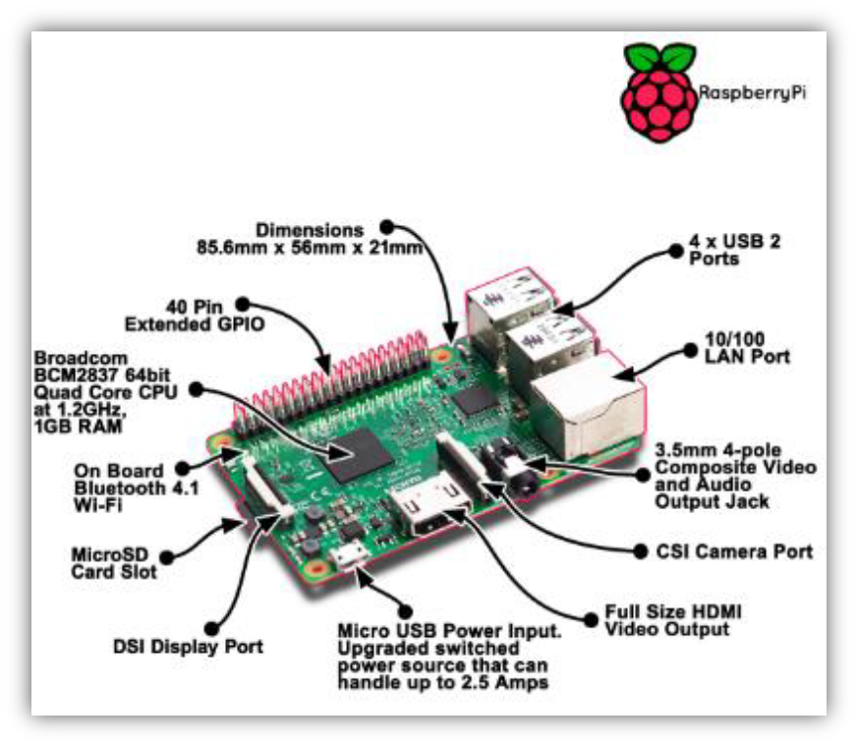Python has user friendly data structure and it takes much less time to development and it has no need of declaring types of arguments and variables. As it provides less coding and better execution output, it is relevant choice to design to get the data from thing speak channel and send it to LabVIEW for further analysis of the collected data.it will be send HTTP request to the thing speak channel using python code. Raspberry pi fetch the health statistic data from the thing speak channel and it will get stored in a text file on raspberry pi. Every time updated value will get stored in text file generated at raspberry pi side continuously.

**Figure 4. 1 Raspberry Pi 3 model B+ ()**

#### 4.2.1.2 Sensors

For developed system requirements, it is required to choose an suitable heartrate sensor for taking correct and accurate reading from patient`s body for predicting and diagnosis the patient`s health. In market research, there are many sensor available for measuring heartrate vital sign in health monitoring system.

* **Types of heart rate monitoring sensors**:

In clinical application heart rate monitor helps to identify patient`s diseases, patient`s health condition based on the heart rate of the patient.

1. **Heart rate monitor that is strapped to the chest:** this is the most accurate heart rate monitor by way of it very nearby patient heart. This types of sensors is very costly.
2. **Pulse type monitor:** in this type of monitoring system sensor sense the heart rate when a finger placed on it. In this type of system drawback is that it is not possible to obtain constant reading and they do not give the accurate and correct result all the time. For example, if figure are very cold then there is chance for giving a false reading.

* **Pulse sensor:**

For the develop system requirements, it is choose appropriate pulse sensor for taking heart rate reading for simulated system because it is very low cost than other sensor and also size is very small so it is compatible with the wearable sensor device. Pulse sensor is an open source hearate monitor sensor built to work with the NodeMCU v0.9.it utilizes periodic sampling of ADC value from the light intensity sensor, and signal filtering to detect the peak-to-peak length in data. The heart rate is measured from the finger tip of the patient. It can also measure from the softer part of the ear lobes [mohanraj T, 2017].

#### 4.2.1.3 IoT module:

**Figure 4. 2 Pulse sensor (T, M., 2017)**

IoT modules are useful to connect host CPU over SPI/SDIO/UART interface and it`s save CPU cost. It can directly integrating with the low footprint SDK and network stack on your CPU. We can easily interface with our product because it`s consume less power, small size and low cost module. Below table shows comparison of different IoT development modules.

**Table 4. 2 IoT Module boards comparison (blog.squix.org, 2015)**

|  |  |  |  |  |  |
| --- | --- | --- | --- | --- | --- |
|  | **NodeMCU V0.9** | **NodeMcu V1.0** | **Wemos D1 Mini** | **Wemos D1 R2** | **LoLin V3 NodeMcu Board** |
|  |  |  |  |  |  |
| Branded | NodeMCU | DOIT | Wemos | Wemos | LoLin |
| GPIO pins | 11 | 11 | 11 | 11 | 11 |
| ADC | 1 | 1 | 1 | 1 | 1 |
| ESP8266 Module | ESP12 (AI-Thinker) | ESP12E (AI-Thinker) | ESP12E (Wemos) | ESP12E (Wemos) | ESP12E (AI-Thinker) |
| USB-to-Serial | yes | yes | yes | yes | yes |
| Serial chip | CH340G | CP2102/CH340G | CH340G | CH340G | CH340G |
| Breadboard friendly | Bad (cover many pins) | Very good | Very good (after soldering) | Bad (Arduino form factor) | Bad (covers many pins) |
| Form factor | Big | Big | Medium | Very big | Big |
| Price | ~$6.40 | ~$6 | ~$6 | ~$6.50 | ~$6.50 |

* **NodeMCU v0.9:**

NodeMCU is ESP8266 open source firmware with Wi-Fi enable IoT development platform. NodeMCU development kit includes ESP8266, integrate GPIO, PWM, IIC, 1-wire and ADC all in one board also includes additional USB to serial UART adapter micro USB port for connect to the computer or other USB host devices and on-board voltage regulator cab be powered through the VIN pin (5-9V). It is used to provide low cost Wi-Fi connectivity to a master MCU, such as Arduino compatible board. In this developed system, NodeMCU collect sensor data and send it to the cloud i.e. on thing speak channel using Arduino IDE Lau based programming language. Below figure shows the pin out diagram of NodeMCU v0.9 module.

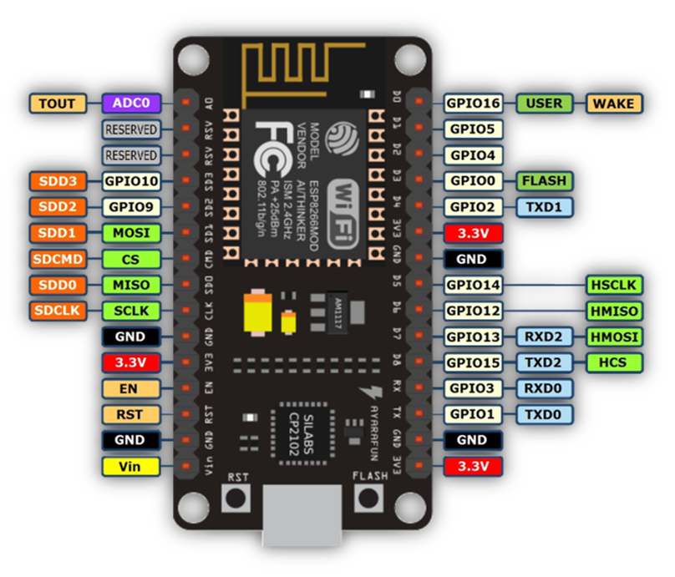

**Figure 4. 3 Pinout Diagram of NodeMCU V0.9 ()**

#### 4.2.1.4 Laptop

To simulate the system and for the result analysis to be presented with all functionality designed minimum requirements for laptop are,

* Windows 7 or above version
* 64-Bit operating system
* Screen resolution : 1024 X 768 pixels
* RAM: 1 Giga Bytes

### 4.2.2 Software requirements

In most of the industries, they are mainly practice to go with simulation design rather than start with an actual product development. By that it is easy to identify any bugs or behavior faults for the system without build it. Design of simulation provides exact behavior of system after implementation in real products. Results are depending on the simulation setup designed. Software plays a key role to design simulation of the system with functionalities.

In the developed system software requirements are also as important as hardware. To improve the result with efficient way, to develop a good system it is necessary to choose appropriate software to design an algorithm of system. Based on the chosen hardware it is discussed in this section to design algorithm for different tasks with better outcome of system.

Some software available for designing the simulation setup are listed in table 4.3.

**Table 4. 3 Software available for simulation design**

|  |  |  |
| --- | --- | --- |
| **Sr. No.** | **Software** | **Language** |
| 1. | LabVIEW | Graphical coding software |
| 2. | MATLAB Simulink® | C, C++, Java, python, and Fortran. |
| 3. | Arduino IDE | C, C++ |
| 4. | Linux | C, C++, Python, java, Pascal, Fortran |

#### 4.2.2.1 Arduino IDE:

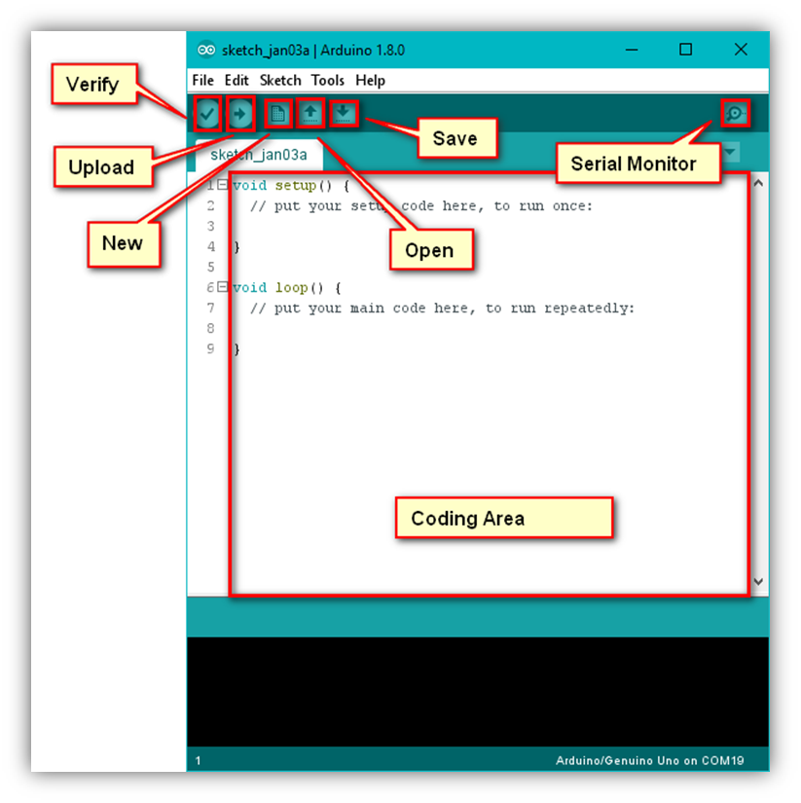Arduino IDE is an open-source electronics platform, it is growing through the contribution of user worldwide based on easy-to-use hardware and software. Arduino IDE script written in in JAVA based on processing programming, AVR-gcc, and other open source platform and it is translated into C language. Programmer can do programming in Arduino programming language and according to wiring, and Arduino software is based on processing programming environment. Arduino (IDE) runs on Mac, windows and Linux operating system. User can easily add AVR C code with Arduino program.

**Figure 4. 4 Arduino IDE software**

#### 4.2.2.2 LabVIEW:

Laboratory Virtual Instrument Engineering WorkBench (LabVIEW) is an interactive graphical programming language that allows for instrument control, data acquisition and pre/post processing of acquired data. In LabVIEW program can be created by graphical symbolization and the principle of dataflow programming, in which functions execute after receiving the necessary data, execution is determine by the structure of a graphical block diagram.

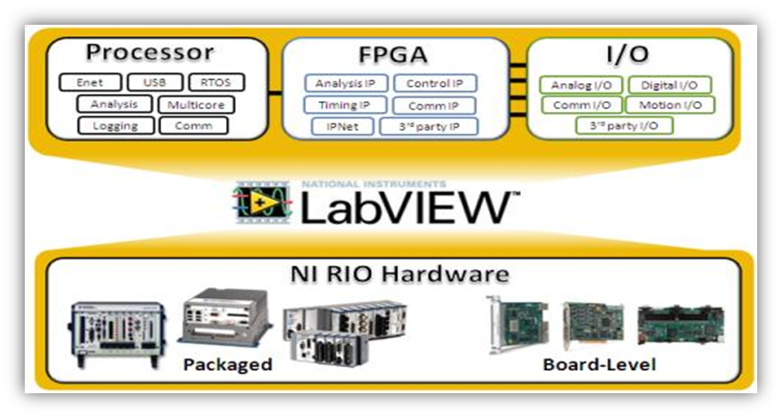A VI has three main parts the front panel, the block (or wiring) diagram, icon/connector. Front panel is one type of window which the user interact with the program. Block diagram window holds the graphical source code of LabVIEW VI and it is actual executable code. Icon characterize the graphical representation in VI block diagram and connector define the input and output of the symbol.

**Figure 4. 5 LabVIEW software**

Programmer can connect different function nodes by drawing wires. When all its data accessible wire spread as variable. This graphical is very beneficial as it enables to assemble programs by dragging and dropping virtual representation of hardware in LabVIEW. LabVIEW provides the additional feature that is include extensive support for interfacing various devices and instruments.

LabVIEW also includes built-in support for NI hardware platforms such as CompactDAQ and CompactRIO, with a large number of device-specific blocks for such hardwares like the *Measurement and Automation eXplorer* (MAX) and *Virtual Instrument Software Architecture* (VISA) toolsets [Mohanraj T, 207].

### 4.2.3 Selected System components and Development costing

From the given functionalities of system and based on all the requirements, chosen hardware and software listed below in table 4.4. As shown, Arduino Uno board have been chosen as hardware and as it is cost effective compared to other boards. Also there is no more requirements for the high configuration board based on system requirements.

**Table 4. 4 Selected system components and total costing for development**

|  |  |  |  |
| --- | --- | --- | --- |
| **Sr. No.** | **System Components** | **Functionality** | **Cost** |
| 1. | Arduino IDE | Establish the Wi-Fi connection | Student edition |
| 2. | LabVIEW | Graphical coding software | Student edition |
| 3. | Raspberry Pi 3 Model B+ | Fetch the data from cloud as well as NodeMCU v0.9 | 375/- |
| 4. | Pulse Sensor | To Measure the pulse | 300/- |
| 5. | NodeMCU V0.9 | Provide Wi-Fi connectivity | 575/- |
| 7. | Connecting wires | To connect all sensors with Arduino UNO | 50/- |
| TOTAL COST FOR DEVELOPMENT OF SYSTEM | | | 1750/- |

For the simulation set up Labview is more effective for graphical representation and it is interfacing with raspberry pi through LINX package. For system design a model LabVIEW software is used. In body monitoring and reporting system using time series analysis it can be design for monitoring a patient`s heart rate and analyze the measured data using ADVANCE Toolkit of Time Series Analysis. NodeMCU and sensor are interface with the Arduino IDE for serial communication.

## 4.3 Design Specification

* When system is initialize, sensor fetch the pulse data from the user body. After Pulse sensor code convert pulse sensor value in heart rate according to beats per minute.
* Calculated heart rate value and transmitted to Raspberry Pi through NodeMCU v0.9 also send to the cloud data base.
* Raspberry Pi fetch sensor data forward to the LabVIEW for further simulation process.
* If the Wi-Fi module and Raspberry pi is disconnected from Wi-Fi connectivity. NodeMCU fetch data directly transmitted to cloud database. After that Raspberry Pi fetch data from the cloud i.e. things speak channel and forward to LabVIEW for further analysis process.
* Raspberry Pi interfacing using LINX with IP address for communication between Pi board and LabVIEW.
* Pulse sensor data compare with the threshold data set value. If the real time data is less than or greater than the Threshold value, developed system identify the abnormality of the diseases.
* If the pulse sensor data is equal or in between range of the threshold set value it return fetch the sensor data continuously.
* Based on the real time data value comparison, developed system predict the future condition using ARMA modelling and prediction time series analysis.
* Based on these predicted value and obtained predicted series results, system will calculate the criticality rate i.e. how much time is critical for the user.
* Based on the criticality rate and predicted series, developed system notify to the person, their relatives and concern personnel consultant in medical domain.
* Based on these predicted value and obtained results it returns the monitoring and reporting system in the designed GUI in LabVIEW.

## 4.4 System Design

System design gives exact idea for the implementation and development stages. It includes, Block diagram, data flow chart, algorithms etc.

### 4.4.1 Block diagram of system

The system can be identified with the flow and directions of its connections with other peripherals and sub components in the system. For the developed system, figure 4.6 shows the high level block diagram of the body monitoring & reporting system with inputs provided to the controller unit for desired results at end of the system.

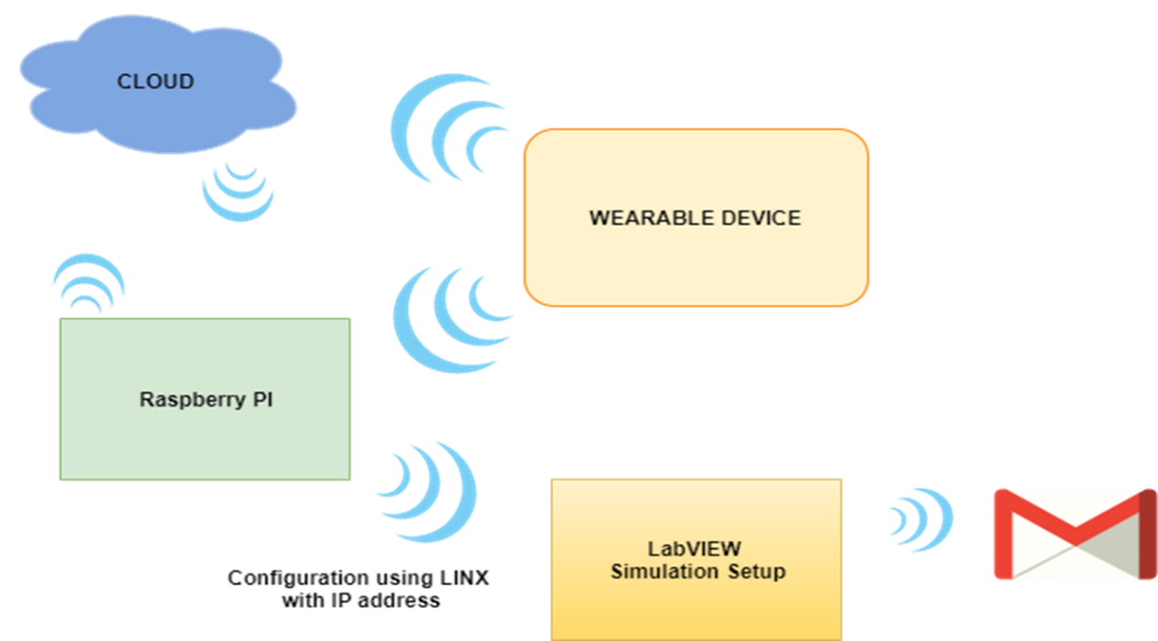Additionally for more detailed outputs the blocks in high level diagram will get divided in to different bio medical sensor modules and also includes ECU with processor and cloud database.

**Figure 4. 6 High level Block diagram for system**

Figure 4.7 depicts the low level diagram of body monitoring and reporting system with connections and direction of communications.

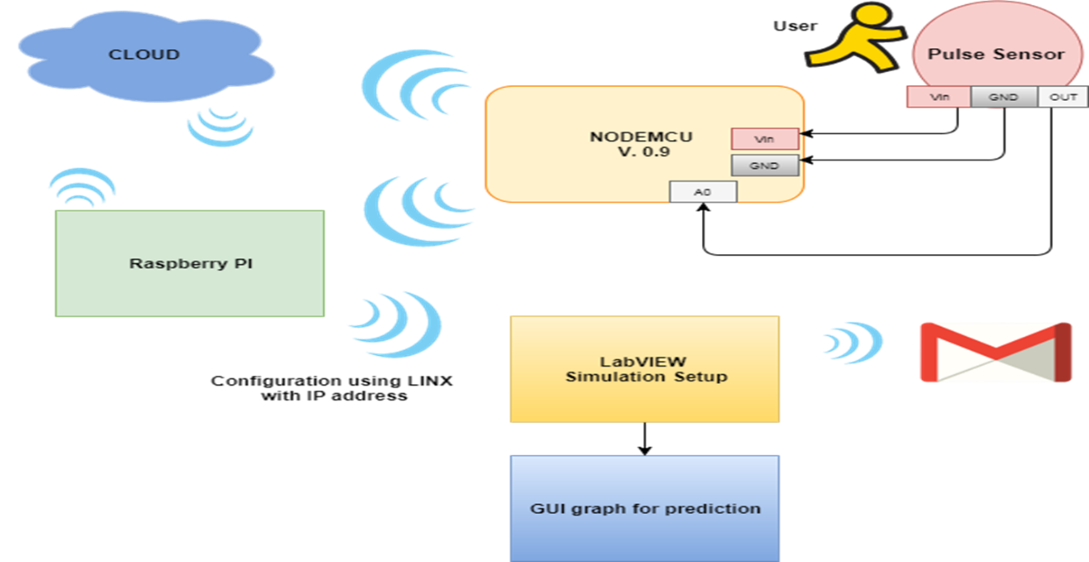The system will measure the data of patient’s body with different biomedical sensors attached as an input stages. Furthermore the data will get fetched and sent over the cloud to create a history of data and for analysis next stage of diagram includes, ECU as a Raspberry Pi board with designed algorithm for analysis. It monitors the abnormality in the patient’s body and if criticality identified it will notify the person.

**Figure 4. 7 low level Block diagram for system**

### 4.4.2 Schematic Diagram

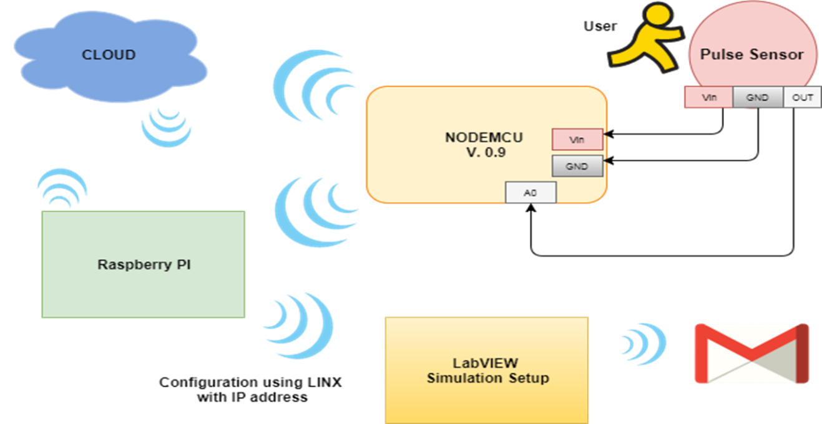Schematic diagram provides visual presentation of the system that describe the interconnection between each sub system and it has enough detail to connect an electronic circuit.

**Figure 4. 8 schematic Diagram of the System**

In Figure 4.8 schematic diagram of the system, Pulse sensor fetch the pulse data from the user`s body. Pulse sensor connected with the NodeMCU V0.9 Module for provide Wi-Fi connectivity accessible between sensor and cloud storage as well as Raspberry Pi. Input voltage and GND pin are connected with NodeMCU pin of input and GND. Output pin of sensor connected with A0 pin of Wi-Fi module. Raspberry Pi Board is configuring using LINX with IP address for communication between Raspberry Pi and LabVIEW. LabVIEW Send email through the SMTP protocol.

### 4.4.3 Flow chart of system

Flow chart of any system will show the actual flow of data as per the system’s functionalities. Figure 4.9 shows the flow chart of prognosis based body monitoring and reporting system with working process. It depicts the actual process of working of system with different stages as shown 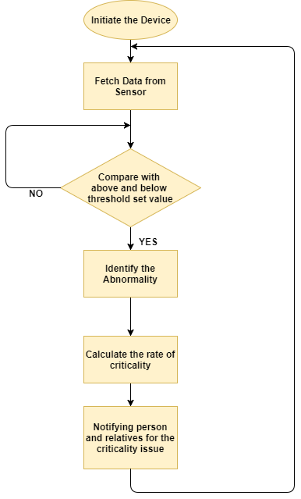below.

**Figure 4. 9 Flow chart of the System**

when system initialise the device it will fetch data from the sensor continuously. After collecting sensor value it will compare fetch data with the normal or threshold set value if the data is greter than or less than the threshold set value it will identify abnormality of the diseases. After that it will calculate data rate of criticality based on the reading collected in real time and predict future condition of the patient. And predicted value get displayed over GUI designed for the simulation set up of the system. All history of the patient data will get stored over a cloud using GUI designed in LabVIEW simulation set up. At the end side system will notify the person, relatives and medical center for the criticality issue. Loop continuously monitoring and fetching the real time data of the patient.

## 4.5 Implementation of System

The implementation is divided into two parts hardware and software implementation. The software implementation is done using Arduino IDE, python and LabVIEW. And hardware implementation includes the sensor, actuators and embedded board.

### 4.5.1 Hardware Setup:

**Figure 4. 10 Hardware setup of System developed**

The figure 4.10 shows the hardware setup for proposed system, based on proposed design. The arrangement of the hardware based on the system requirement. NodeMCU v0.9 Wi-Fi module is used for data fetch from sensor and transmit to the cloud storage as well as send to the Raspberry Pi. Raspberry pi is used for sensor data fetch from cloud and transfer to the LabVIEW for further analysis of the real time data.

### 4.5.2 Software Setup:

Software set up is a part of the developing process to getthe software part of the system. There are three different software used for developing the system. Arduino IDE is used to dumb the code in NodeMCU V0.9 Wi-Fi module. LabVIEW is used to analyzing and predicting the patient`s future condition based on the real time data. Python code is used for communication between Raspberry pi and LabVIEW.

#### 4.5.2.1 Simulation set up of NodeMCU and Arduino IDE:

**Step 1: Downloading and installing the Arduino IDE**

**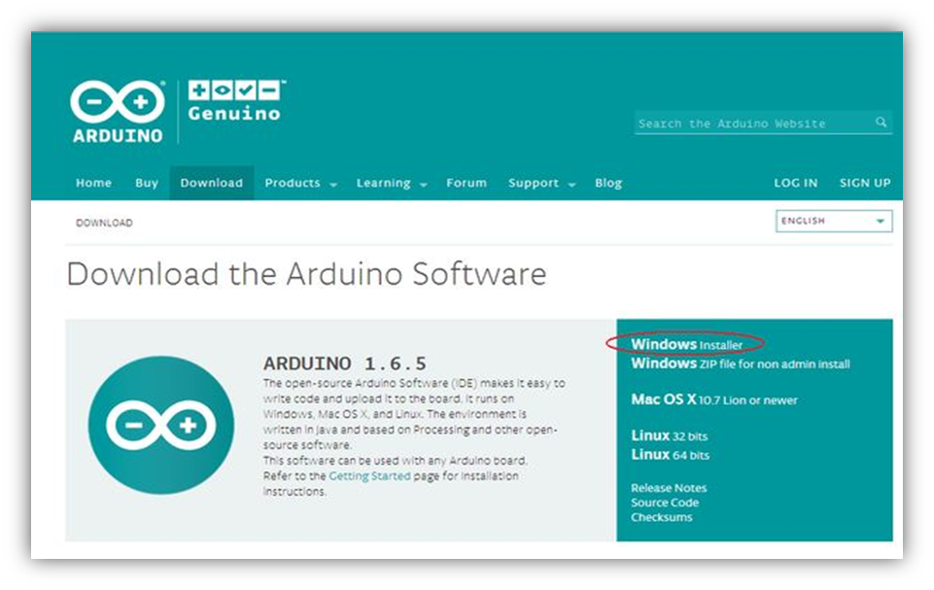****Figure 4. 11 Installing IDE**

**Step 2: find the preference dialog.**

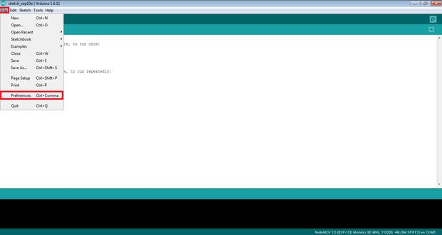First open the Arduino IDE and go to file menu select the preference click on it. After that it will open the preference dialog box it is shown in below figure 4.12.

**Figure 4. 12 Preference Dialog box**

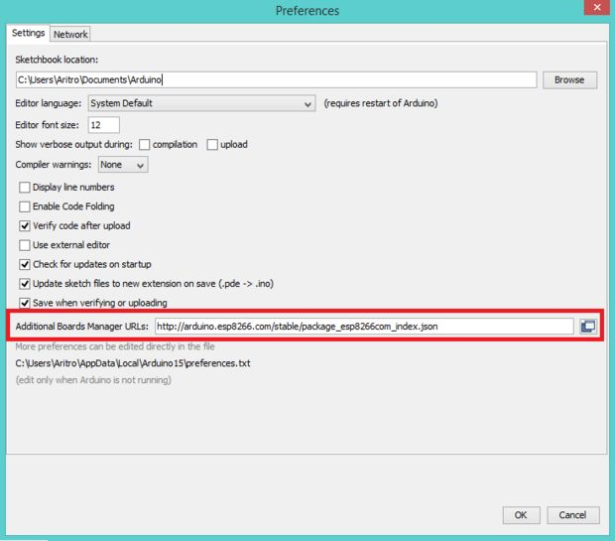In this figure 4.13 preference dialog box we have to need give URL of the ESP8266 data package path.

**Figure 4. 13 Preference Dialog box for URL Path**

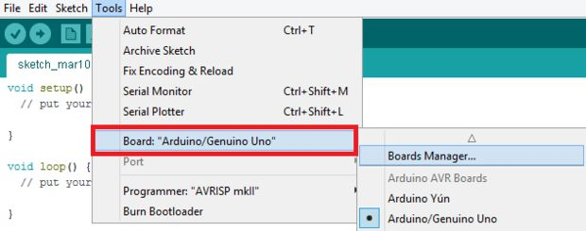**Step 3: where to find Board manager dialog**

**Figure 4. 14 Board manager Dialog**

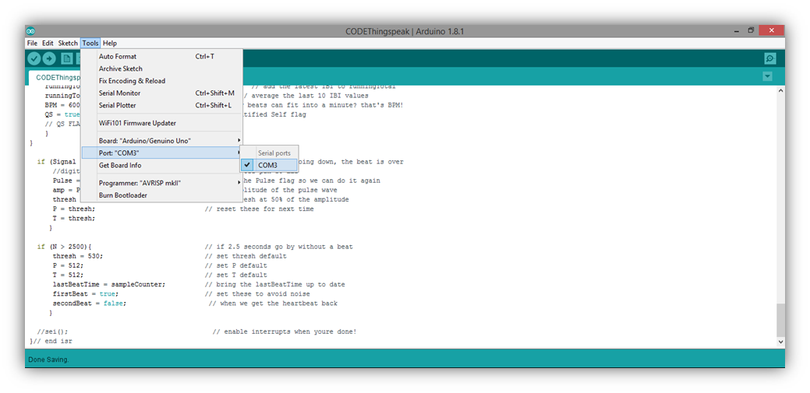**Step 4. Determining the COM port**

**Figure 4. 15 Determining COM port**

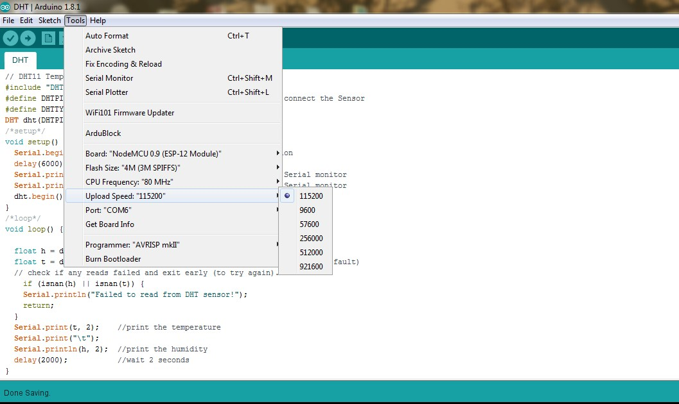**Step 5** **. Configuring the COM port Speed**

**Figure 4. 16 configuring COM port Speed**

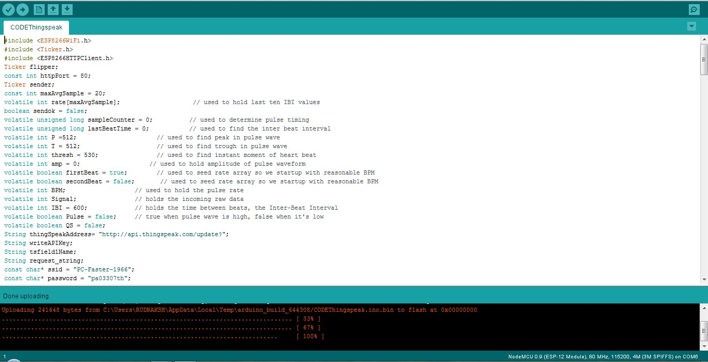**Step 7. Test Drive the Set up.**

**Figure 4. 17 Upload the code**

#### 4.5.2.2 Simulation Set-up in LabVIEW:

LabVIEW simulation Set-up designed is graphically code representation of the developed system design. For create a project for developed system some basics step required to follow which is enlisted below with screenshots,

**Step 1:** Start LabVIEW software.

**Step 2**: Go to create project option and click on it.

**Step 3**: in figure 4.18 select the blank project and click on finish button. It will give the prompt with project tree which is includes sub Vis configuration window.

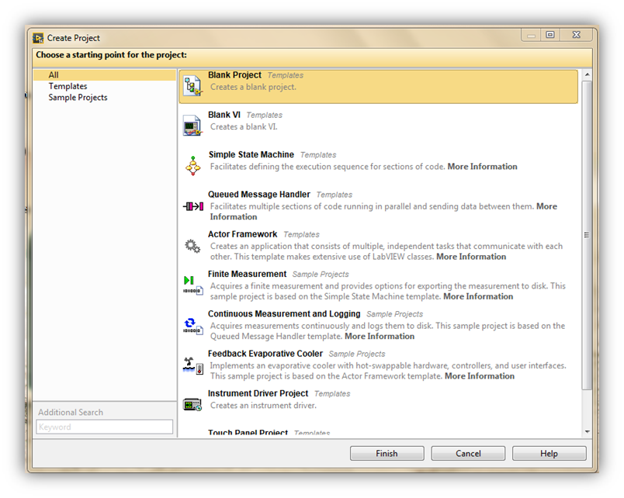**Step 4**: for create a new VI go to My Computer option and click on it in given window. Shown in Figure 4.19

**Figure 4. 18 Create Project**

**Step 5:** After creating a new project VI it will give blank block diagram window for develop system design and front panel windows for develop GUI for designed system shown in figure 4.20, 4.21

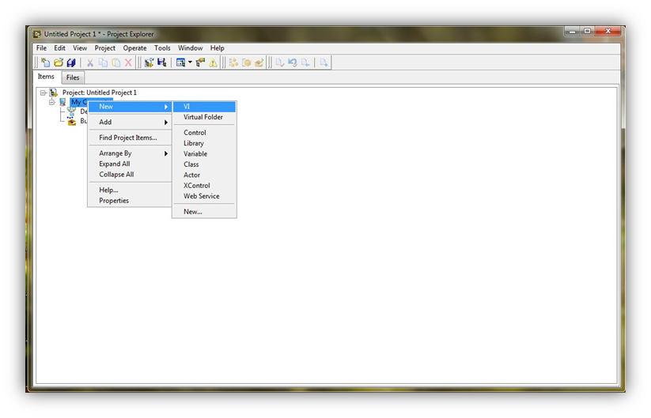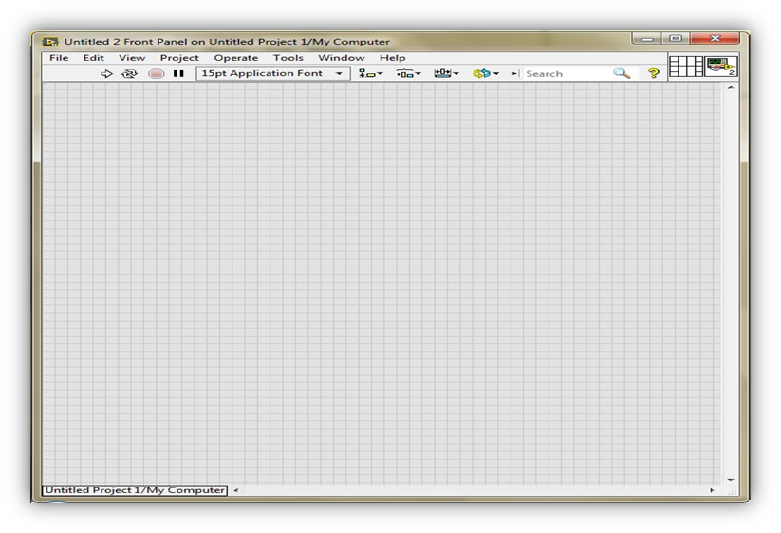

**Figure 4. 19 Create a new VI**

**Figure 4. 20 Front panel window for Create project**

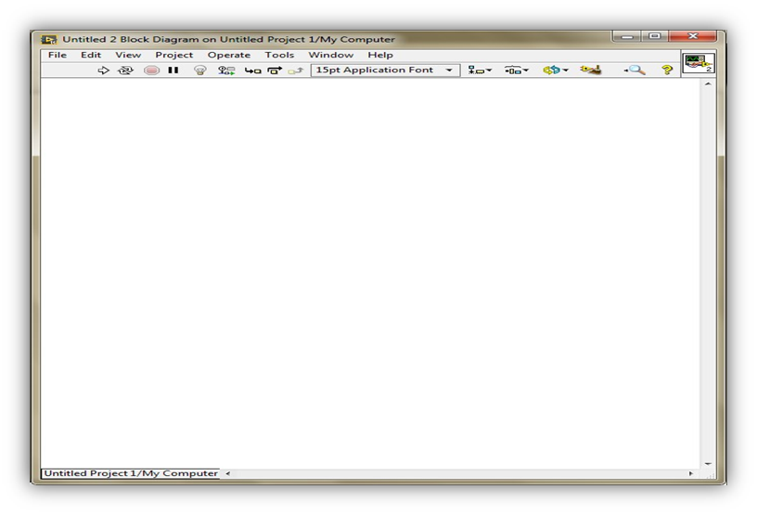

**Figure 4. 21 Block Diagram Window for Create new Project**

### 4.5.3 System Implementation and Design in LabVIEW

#### 4.5.3.1 Implementation between NodeMCU and Arduino IDE

In Arduino IDE software, the scholar is going to write the code for read the pulse sensor data and transmit to the cloud. Code for pulse sensor.

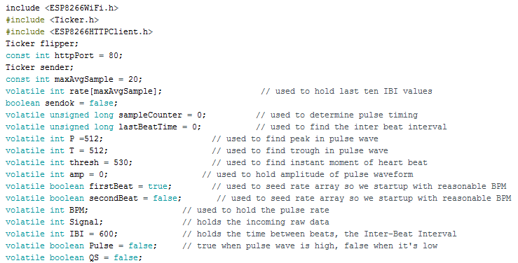

**Figure 4. 22 Initialization of library**

Here, above figure 4.22 has code for initialization of library for ESP8266 Wi-Fi module, ESP8266HTTPCLIENT service and Ticker.h library used to set up a recurring interrupt to repeatedly call a function at a specific rate. After initialization of the libraries we have to initialize variables for future purpose.

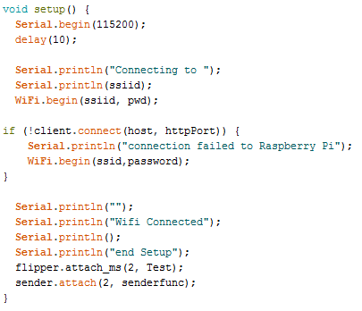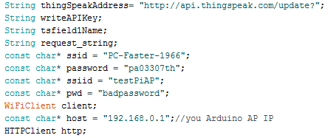In above figure 4.23 and 4.24, Set the thing speak channel address and SSID and password of Wi-Fi connection. Then it will send the request to the server for establish connection to thing speak URL and set the KEY of the thing speak channel for read and write the data on thing speak channel. And print Wi-Fi connected on serial monitor of Arduino IDE.

**Figure 4. 23 Print the Wi-Fi is connected**

**Figure 4. 24 Set password and SSID for Wi-Fi connection**

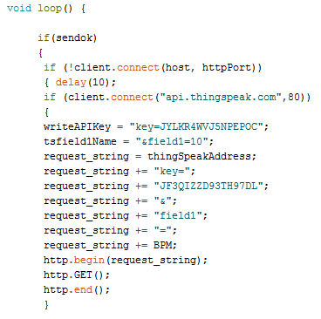

**Figure 4. 25 Set Thing speak channel KEY**

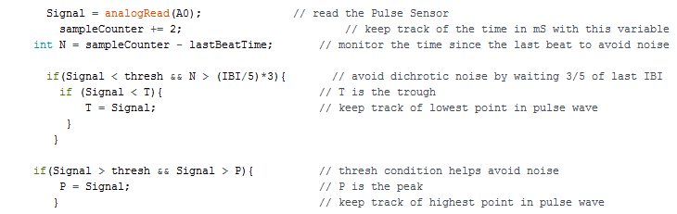in above snippet 4.25, make loop for data fetch from sensor to cloud and set the write and read key given by thing speak channel and send the HTTP client request.

**Figure 4. 26 Pulse Sensor Code**

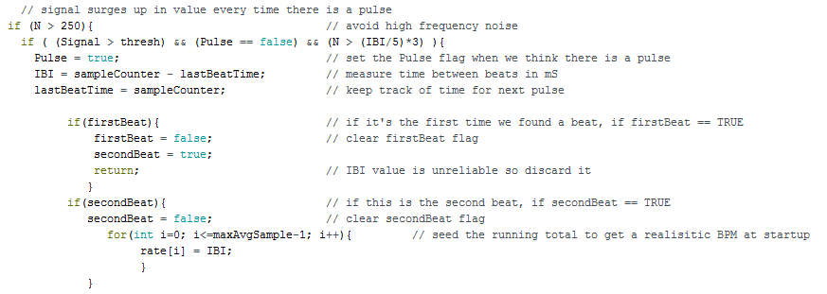In this figure 4.26, signal read the analog value of the pulse sensor through A0 pin after set the counter value by increasing one. LastBeatTime variable helpful for monitor the time and removing the noise from sensor data. After that signal compare with the threshold value and it helps to avoid dichrotic noise.

**Figure 4. 27 Fetch Pulse Value**

now in figure 4.27, it is looking for the heart beat rate and signal flows up in every value according to the patient`s pulse data. It will continuously monitoring and fetch the pulse rate increasingly one by one till condition is TRUE.

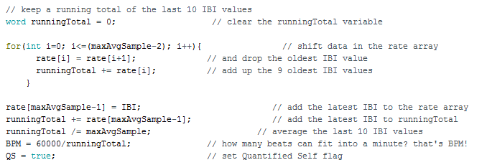

**Figure 4. 28 SET Counter value**

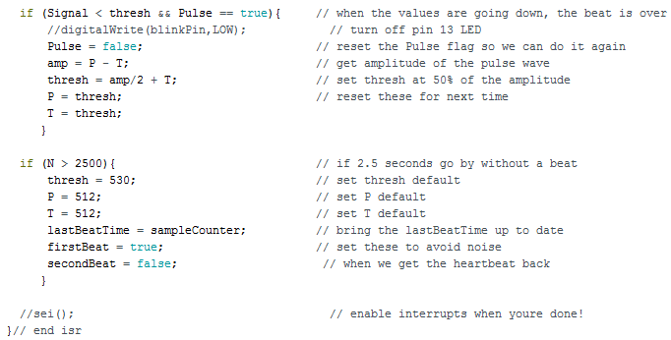Every IBI i.e. beat per minute value stored in rate array up to 9 oldest IBI value. After it will add all oldest IBI value calculate average of the last 10 IBI value and check out how many beats can fit in to a minute.

**Figure 4. 29 calculate Heart rate**

in end of the figure 4.29, when the value are going down then the set threshold and peak value, the beat is over after that it will reset the Quantifies self-flag and get the amplitude of the pulse wave and set threshold value 50 % of the amplitude. After it will reset for next time.

#### 4.5.3.2 Design in Labview Using TSA ARMA Modeling and Prediction:

**Figure 4. 30 ARMA Modelling and Prediction in LabVIEW**

Table 4.5 shows the working and functionality for each blocks used in the ARMA model and prediction block diagram for Body monitoring and reporting system. Blocks used explained with its basic usage for the designed system as in block diagram shown in figure 4.30.

**Table 4. 5 Functional blocks and its working**

|  |  |  |
| --- | --- | --- |
| **Functional Blocks** | **Symbols** | **Working** |
| **Read from the text file function** |  | In this block, prompt function open that appears above attach list of files and file dialog box used to display select file. If the relative file path does not exit, this function returns an error. Count function is read to maximum number of character. Refnum out is the Refnum of the file. Text read the data from file. Cancelled function useful for check the condition, if the file path is correct it will read the file data otherwise return an error and error out contains error information. |
| **String to byte array function** |  | This function is used to convert the character to ASCII value. |
| **Sawtooth** | C:\Users\Pari Patel\Downloads\s.png | Sawtooth Function generate the sawtooth value and plot the graph according to given input data. |
| **While Loop** |  | In while loop, sub-diagram contains code that the while loop execute once per iteration and iteration terminal provides the current loop iteration. Count conditional terminal executes the input value to determine continue executing the while loop |
| **Wait function** |  | Wait function specifies how many milliseconds to wait for execute the function twice |
| **IIR Filter** |  | In this block, init/cont provides control of the internal state. X is the input array of sample to filter. Reverse and forward coefficient set according to data for filter design. Filter X shows the array of filtered sample as output |
| **TSA ARMA modelling VI** |  | Xt specifies the univariate time series. Method estimating the ARMA model. High order AR method used to computes the Autoregressive (AR) and Moving average (MA) coefficient with AR model. In this method AR and MA coefficient values are default set 4 and 3 respectively, Otherwise it must be equal to or greater than 0. Noise returns the estimated white noise. |
| **Build Array function** |  | This function wired the input element or 1-D array to appended array. |
| **TSA prediction** |  | In this block AR and MA coefficient obtained using ARMA modeling. Error in identify the error condition if the error occurred before node runs. Predicted series returns the predicted univariate time series and standard deviation provides the deviation of each predicted value. |
| **Waveform graph** | C:\Users\Pari Patel\Downloads\wf.png | It will generate the waveform to output of predicted value. |

#### 4.5.3.3 Graphical User Interface in LabVIEW:

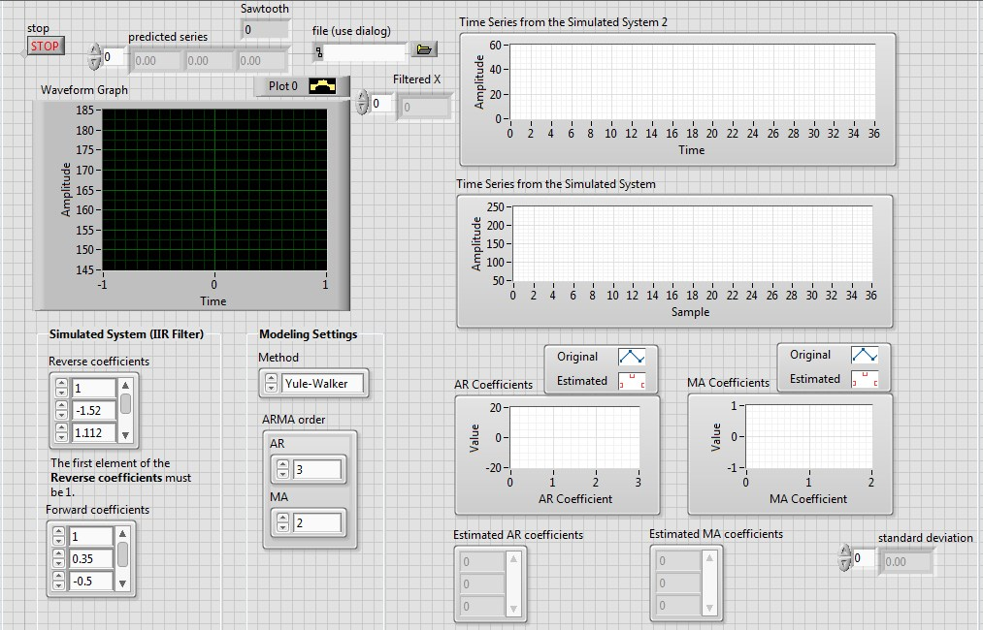In figure 4.31, Predicted Series shows the predicted value sawtooth box shows showtooth value of the raw data and filter. Reverse coefficient and forward coefficient set by Ni Instrument. High order AR method is used for ARMA modeling and Prediction. ARMA order set according to our requirement. In AR coefficient graph Blue line indicate the original value and red dots indicate estimated value. Estimated AR and MA coefficient used for predict the future value. Standard deviation give the error between original data and predicted data.

**Figure 4. 31 Graphical User Interface for ARMA Modeling and Prediction**

#### 4.5.3.4 Design in LabVIEW for SMTP protocol:

**Figure 4. 32 SMTP Protocol Design**

**Figure 4. 33 SMTP Protocol design**

In figure 4.33 first, we have to set all the information about sender and recipient`s address and name and it will forward to the mail message and enter Carbon copy recipient address after that check the condition if user entered a CC address, process is done and mail forward to attach body message or any attachment file.

In figure 4.32 after forward for attach body message or any attachment file it will check condition. If condition is true i.e. user selected an attachment and forward to smtpclient for sending the message. When SSL button is enable it will give accessibility to network connectivity for sending the e-mail.

#### 4.5.3.5 GUI design in LabVIEW for SMTP Protocol:

**Figure 4. 34 GUI Protocol for SMTP Protocol**

#### 4.5.3.6 Communication between Raspberry Pi and Cloud:

**Figure 4. 35 Python code for fetch data from cloud**

Figure 4.35 shows python code for the data fetch from thing speak channel to raspberry pi. For communication between raspberry pi and cloud we have to initialize the library i.e. import urllib2 and json. Then READ_API_KEY and CHANNEL_ID shows the API_KEY and ID of the thing speak channel created. Urllib2.urlopen give permission to access to read data from given thing speak channel authenticated with thing speak channel key and id defined. Connection established with conn.read() function and json.load(response) give the response to generated channel code. Data read from the channel will get printed on the console with given parameters and that same data will get stored in the text file created after that. For the continuous working the same system the code is executed with infinite while loop condition. Every time after updating the value in the text file the connection will get closed.

## 4.6 System Integration:

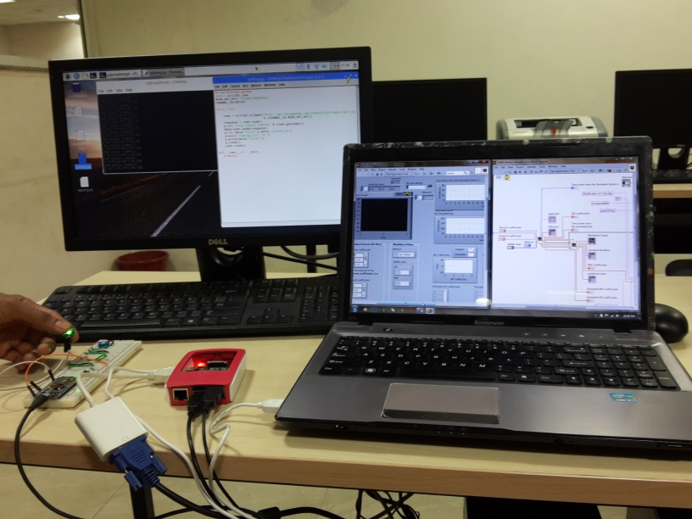After implementation done on software to design the simulation of system to calculate criticality rate based on the predicted series value, it is required to integrate all the parts i.e. hardware and software for testing the system and to obtain the results. As shown in figure 4.36, the system integrated with LabVIEW using LINX and the analysis results obtained is discussed in next chapter with details.

**Figure 4. 36 System setup after Integration**

# 5. Results and Discussions

In this chapter of dissertation work after the developed system tested for the working functionality. The body monitoring and reporting system developed and implemented is tested based on unit testing, integration testing and system level testing.

The testing is done with the developed simulation setup in LabVIEW and Arduino IDE. LabVIEW and Arduino IDE code tested and shown results for each type of test cases carried for that system.

All test cases developed discussed in this chapter and based on the results for each test cases the developed system tested at integration and system level.

## 5.1 Unit Testing

Unit testing for any system is done with each component and functionality of the individual component for system. It comprises both types of testing software simulation side and hardware side.

In this testing it involves to test the functionalities of pulse sensor in Arduino IDE for the developed system.

* To test functionality of pulse sensor as analog reading in Arduino IDE.
* To test functionality of NodeMCU v0.9 as Wi-Fi module is connected in Arduino IDE.
* To test functionality of Raspberry pi after installing the operating system (OS).
* To test functionality of SMTP GUI as a send e-mail.

For the develop test cases, table 5.1 shows all test cases with the expected result.

**Table 5. 1 Unit testing for hardware**

|  |  |  |  |  |  |  |
| --- | --- | --- | --- | --- | --- | --- |
| **Unit Test Case ID (UTC)** | **Test Case** | **Input Data** | **Test Process** | **Expected Result** | **Actual Result** | **Figure**  **No.** |
| UTC_01 | Pulse sensor value given as input to Arduino IDE using NodeMCU | Pulse sensor value | Connection establish by the NodeMCU and it is connected to Arduino IDE | Should show the analog value according to real time data | Giving immediate response for the change in analog values | 5.1 |
| UTC_02 | NodeMCU working | NodeMCU connected to PC with | whether LED is blink or not | LED should blink | LED blink | 5.2 |
| UTC_03 | Raspberry Pi working | Raspberry Pi connected to PC by Serial cable. | After installing OS it will check whether it work or not | Board should work properly | Fetch the data from cloud and transmit to the LabVIEW | 5.3 |
| UTC_04 | SMTP Protocol testing | Recipient`s Address | Send the message to recipient | E-mail should be send | E-mail sent successfully | 5.4 |

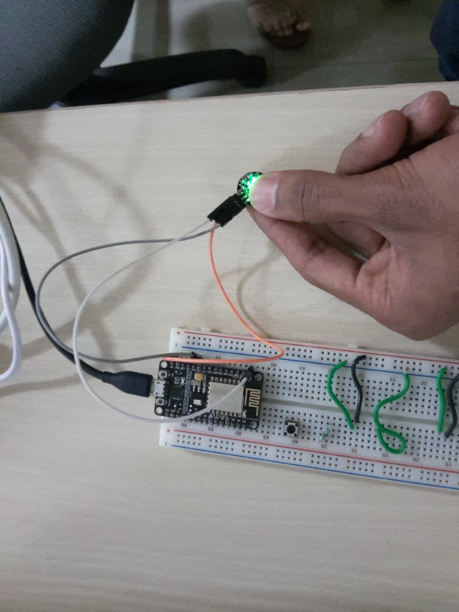The unit testing is done to verify the functionality of the system develop with the simulation set up built for taking input value from the sensor of the system. As shown in figure 5.1 to 5.4 are expected for the unit test cases.

**Figure 5. 1 pulse sensor Testing**

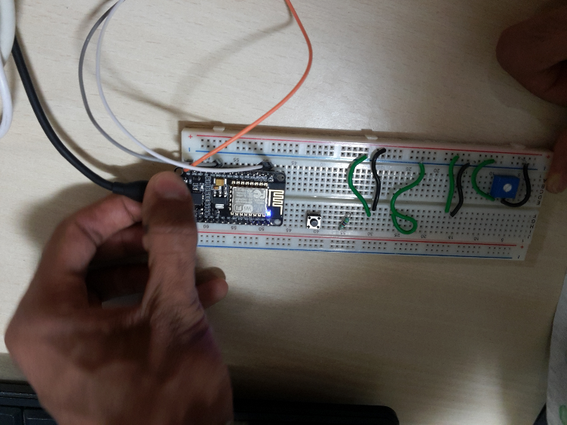

**Figure 5. 2 NodeMCU V0.9 Testing**

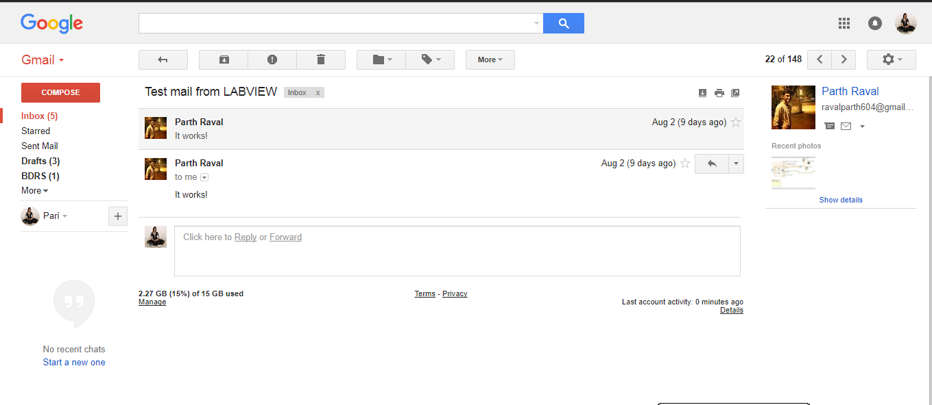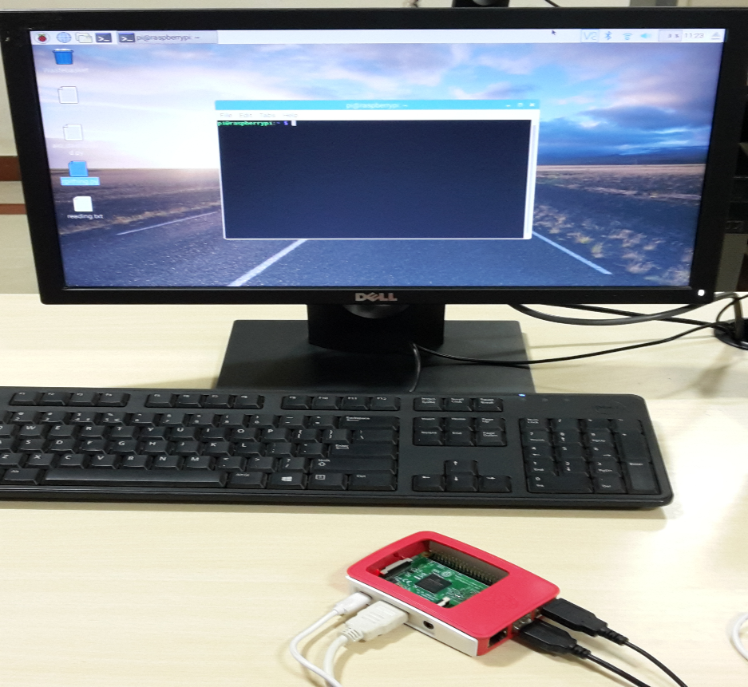

**Figure 5. 4 SMTP Protocol Testing**

**Figure 5. 3 Raspberry Pi Testing**

## 5.2 Integration Testing

For the integration testing sub system will combined and tested together. For integration testing consider following test cases,

* To test for sensor data send to Raspberry pi.
* To test for sensor data fetch from cloud to Raspberry Pi.
* To test for sensor data send from NodeMCU V0.9 to cloud.
* To test for sensor data transmit from Raspberry pi to cloud.

Table 5.2 shows all test cases carried out for integration testing of the system. It includes the test procedure and results as obtained for each of them.

**Table 5. 2 Integration Testing**

|  |  |  |  |  |  |
| --- | --- | --- | --- | --- | --- |
| **Integration Test Case ID (ITC)** | **Test Case** | **Input Data** | **Test Process** | **Expected Result** | **Actual Result** |
| ITC_01 | To test the sensor data to Raspberry Pi | Input comes as an analog value from Pulse sensor | NodeMCU sense the data from pulse sensor and send it to Raspberry Pi Access point | Should able to send sensor data to Raspberry Pi | Pulse sensor data successfully sent to Raspberry Pi |
| ITC_02 | To test for fetch sensor data from cloud to Raspberry Pi | Wi-Fi connection | Whether it will check Wi-Fi module is connected or not | Wi-Fi connection should be establish | Wi-Fi connection successfully establish |
| ITC_03 | To test for send sensor data from NodeMCU V0.9 to Cloud | 5V Battery | Establish the connection and send sensor data to cloud through NodeMCU | Pulse sensor data should be send to cloud | Pulse Sensor data successfully sent to cloud |
| ITC_04 | To test for transmit the sensor data from Raspberry Pi to cloud | Wi-Fi connection | Whether it will check Wi-Fi module is connected or not | Wi-Fi connection should be establish | Wi-Fi connection successfully establish |

## 5.3 System level Testing

For the system level testing some test cases can be given as,

* To test functionality for NodeMCU to Raspberry Pi.
* To test for Raspberry Pi fetch data from cloud.
* To test Prediction in LabVIEW.

**Table 5. 3 System level testing**

|  |  |  |  |  |  |
| --- | --- | --- | --- | --- | --- |
| **System level Test Case ID (ITC)** | **Test Case** | **Input Data** | **Test Process** | **Expected Result** | **Actual Result** |
| STC_01 | To test NodeMCU to Raspberry Pi and Cloud | Input analog signal came from the Pulse sensor | NodeMCU will fetch the data from Sensor and send it to the Raspberry Pi Access point and cloud database. | Data should be send to Raspberry Pi as well as Cloud | Data successfully sent to Raspberry pi and cloud |
| STC_02 | To test for Raspberry Pi fetch data from cloud | Wi-Fi connectivity | If Wi-Fi connection is establish, Raspberry Pi input analog data fetch from the cloud for further analysis | Should Analog input data fetch from the cloud database | Analog input data successfully read from the cloud storage. |
| STC_03 | To test prediction in LabVIEW | From Raspberry Pi i.e. text file | Text file give to LabVIEW and it will predict the estimated value using ARMA modelling and Prediction | Should give predicted data series according to Pulse sensor data | System given predicted data series according input data file |

## 5.4 Result Analysis

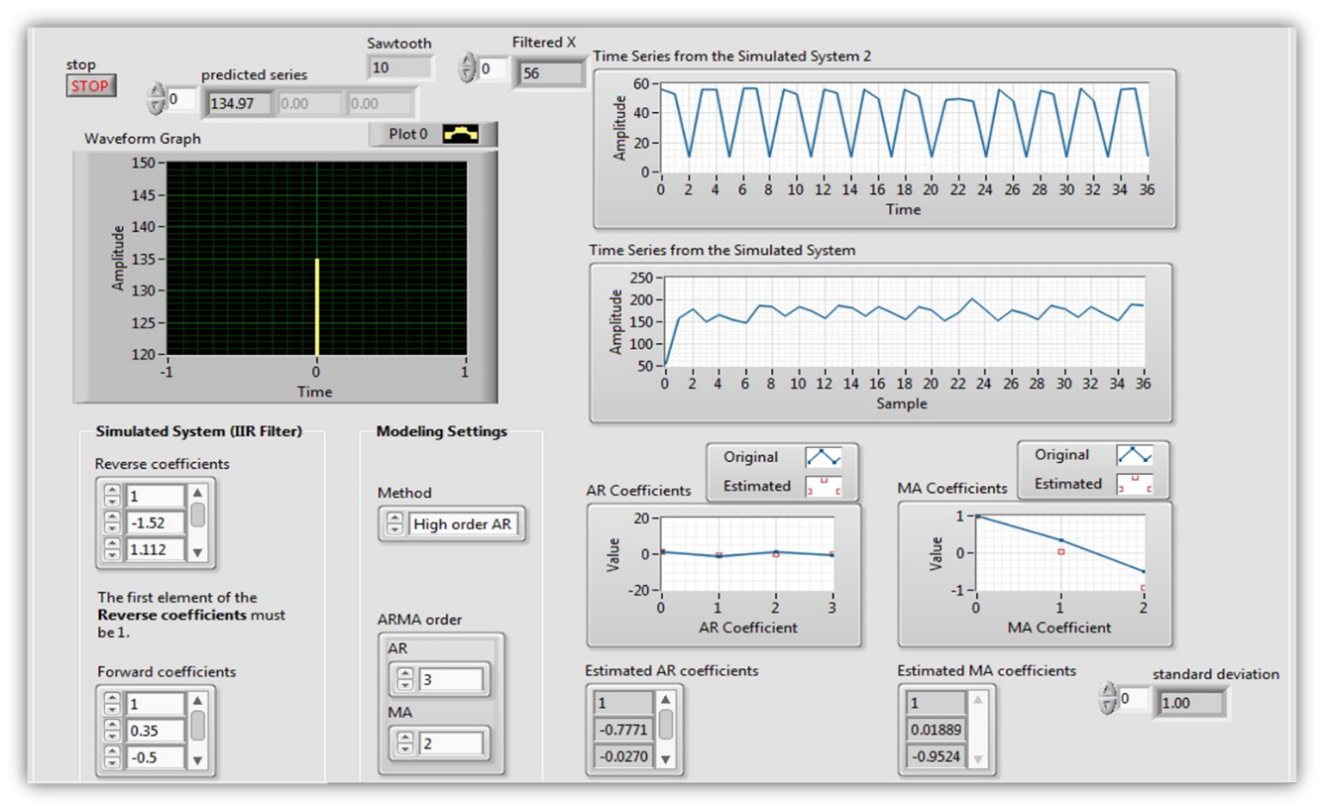Based on the addressed problem identification and the requirement analysis done on the research gaps. The system proposed with some additional solutions. After implementing the system on hardware and simulation design done on software chosen, Results for the developed system are shown in this section of the thesis. Results obtained are for some analog signal values collected from Pulse. These pulse sensor data sent to cloud as well as Raspberry Pi through NodeMCU V0.9 module. Raspberry Pi will send the data to LabVIEW for further analysis. After that LabVIEW predict the patient`s criticality state and alert to user as well as health care taker. Based on implemented design and logic applied for the system, results shows the considerable improvement for Body monitoring and Reporting System.

**Figure 5. 5 Results of Predicted Series**

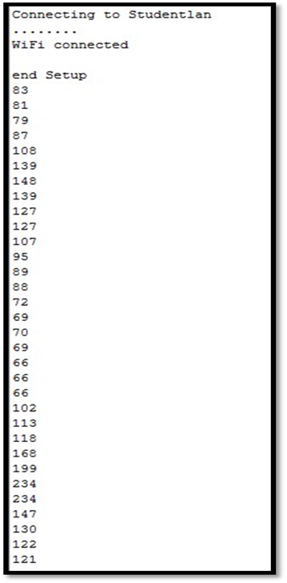above figure 5.6 shows the real time data fetch from the user`s body through pulse sensor. Fetch data shows in Arduino IDE of serial monitor. It also shows the Wi-Fi connection is establish and print all real time data of users.

**Figure 5. 6 Pulse sensor Reading**

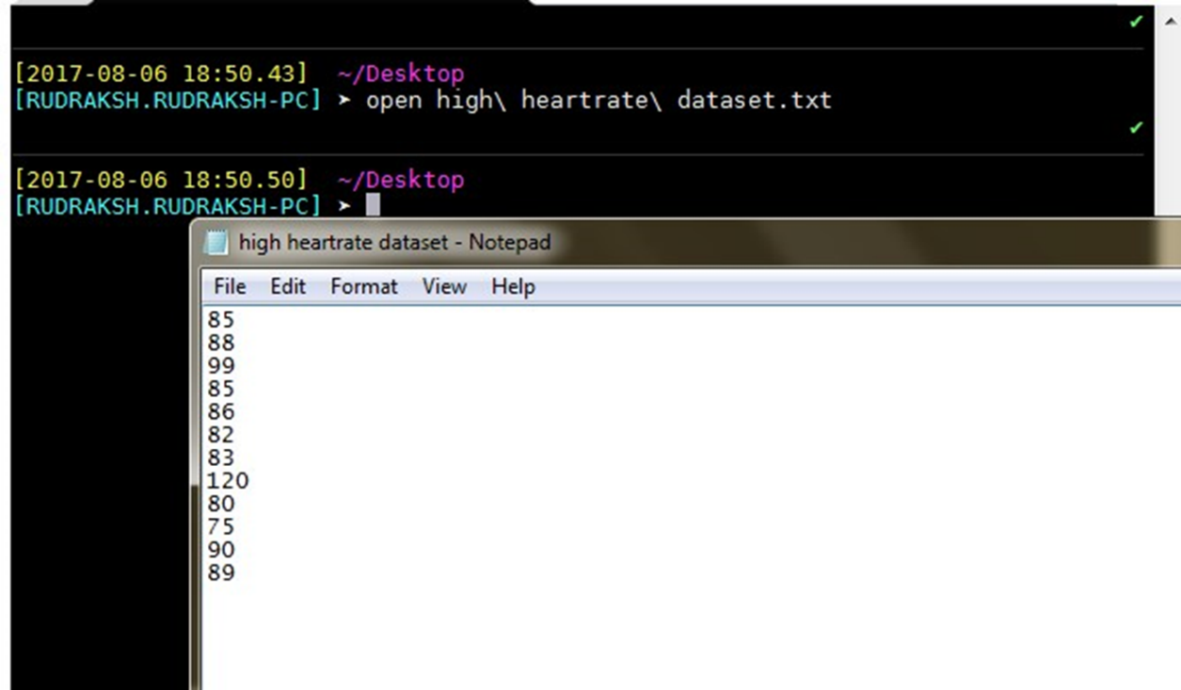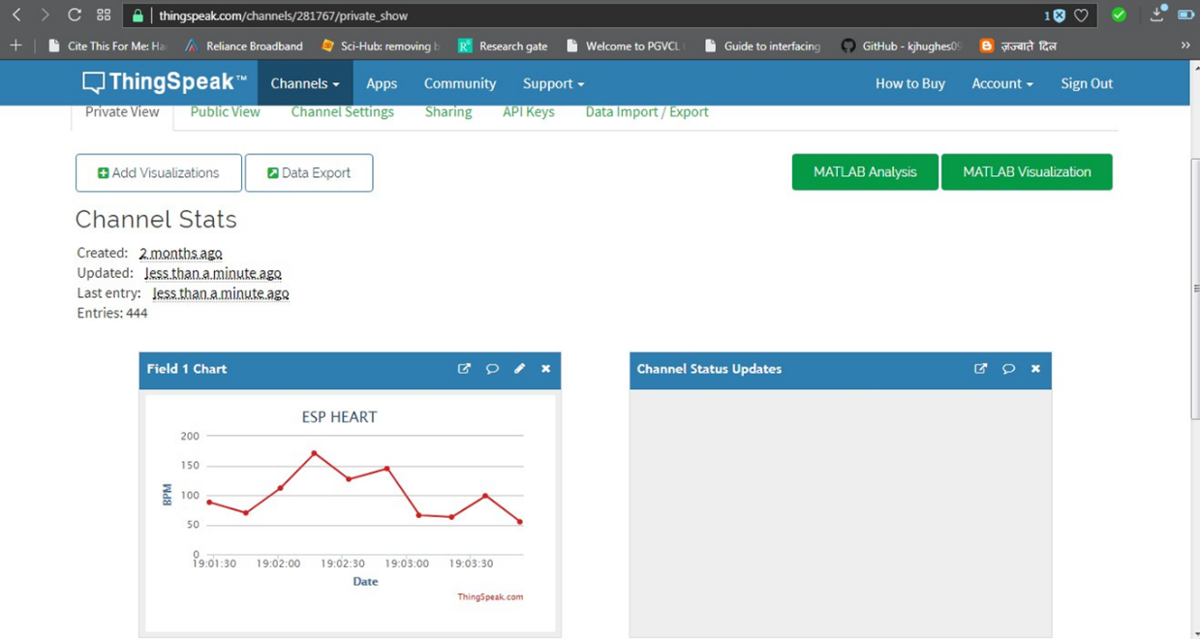In figure 5.8 shows fetch sensor data forward to could i.e. thing speak channel and shows the real time data graph and value. In figure 5.7 shows Raspberry Pi data fetch from cloud and file convert into text file format.

**Figure 5. 7 Raspberry Pi convert Data file into Text file**

**Figure 5. 8 Sensor Data send to cloud**

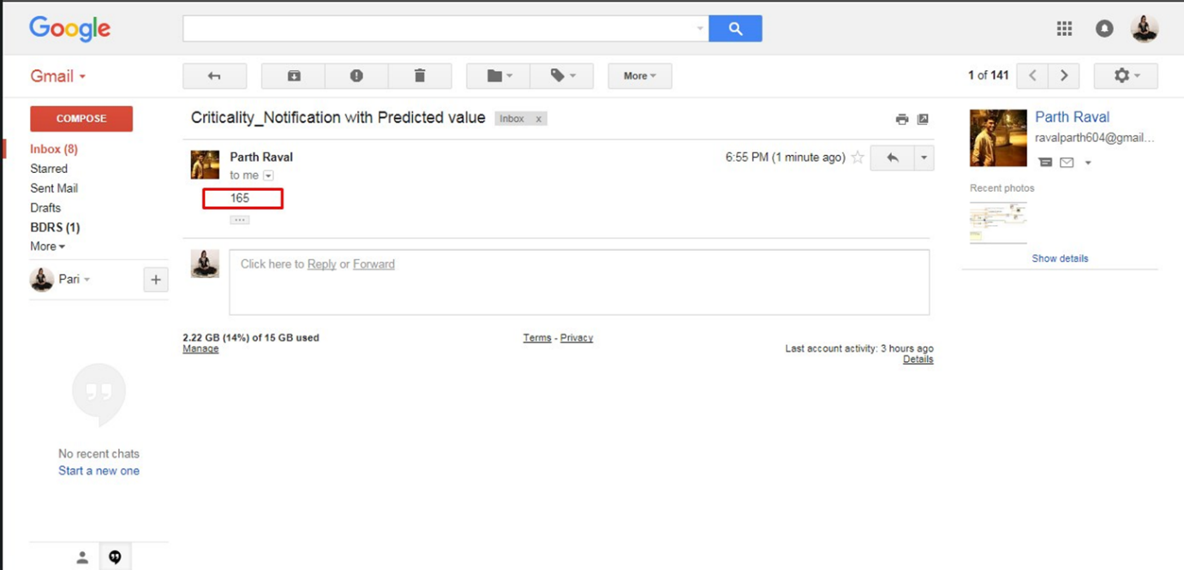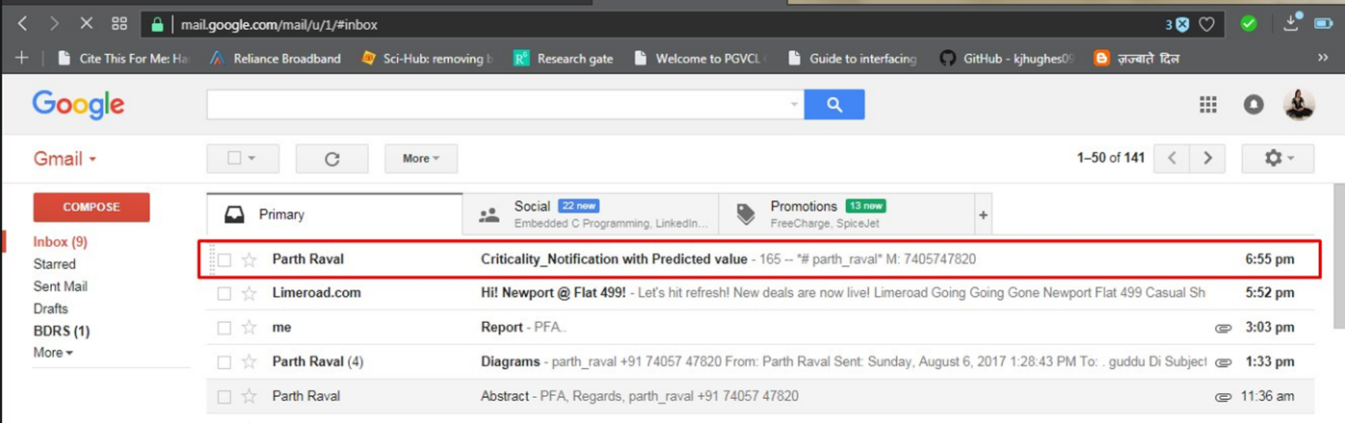in figure 5.10 shows get the notification E-mail through SMTP protocol designed in LabVIEW, if the abnormality occurred and user`s health in critical situation. Figure 5.9 shows get E-mail with predicted value and text message from criticality of disease.

**Figure 5. 10 GET Criticality Notification through E-mail**

**Figure 5. 9 Get E-mail with Predicted Value and message for Criticality of disease**

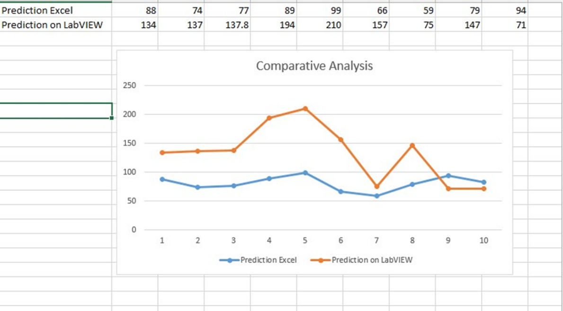Above figure 5.11 shows the standard error deviation between theoretical and practical predicted value. From this analysis graph we can identify the system accuracy.

**Figure 5. 11 Prediction Accuracy Difference between EXCEL and LabVIEW**

# 6. Conclusions and Future Directions

## 6.1 Summary of Work

As Human health is getting affected by various factors from an environment such like, simple health issues e.g. Fever, Flu, Viral infection etc., it is required to develop a system to secure the patient’s health before the critical state to be reached. Developed prognosis based Body monitoring and reporting system using ARMA modeling time series analysis can be used to measure current situation of patient’s health and can also be used to identify the criticality rate for the person before it going to meet abnormal condition.

It can be conclude from the obtained result that, there is significant change in heart rate it will identify the abnormality of disease. Based on prognosis condition system will predict the future condition of the user and notify the user or medical experts. It calculates the criticality rate which plays major role in the system and obtains results for the disease which will helpful to control it before the critical situation to be occurred.

System features can be expand by adding more vital sign parameter other than heart rate. The efficiency of the system can be improved by designing a new methods and algorithms.

## 6.2 Conclusion

* Pulse Sensor readings transmitted to Raspberry pi and cloud through NodeMCU V0.9 Module.
* Raspberry Pi fetch the data and transmit to designed system
* Critical rate calculated from the predicted value and identify the abnormality of the disease.
* The predicted value sent through SMTP protocol from LabVIEW to registered e-mail account.

## 6.3 Future Work

It is important aspect to consider the future expansion of any developed work and to concentrate on future scope of the implemented work. Some future extensions can be consider for the developed Prognosis and Diagnosis based Body monitoring and reporting system as,

* System can import More than one vital sign parameters included in the developed system.
* In future work system can be provide solution for the avoidance of the critical state.
* Scalability and accuracy can be improve by implementing new algorithm for gateway medium.

# References

Aruna Devi.S, Godfrey Winster.S, and Sasikumar.S, (2016). Patient Health Monitoring System (PHMS) using IoT devices, International Journal of Computer Science & Engineering Technology (IJCSET), 7(3), pp. 68-73

Hassanalieragh, M., Page, A., Soyata, T., Sharma, G., Aktas, M., Mateos, G., Kantarci, B. and Andreescu, S. (2015). Health Monitoring and Management Using Internet-of-Things (IoT) Sensing with Cloud-Based Processing: Opportunities and Challenges. 2015 IEEE International Conference on Services Computing.

Megha Koshti, and Prof. Dr. Sanjay Ganorkar, (2016). IoT Based Health Monitoring System by Using Raspberry Pi and ECG Signal. [online] Ijirset.com

Jimenez, F. and Torres, R. (2015). Building an IoT-aware healthcare monitoring system. 2015 34th International Conference of the Chilean Computer Science Society (SCCC).

SATPUTE, M., SAHANI, M., SURAVASE, M., THOMBARE, M., MAHAJAN, P. AND CHAVAN, P. V. (2016) Health Parameter Measurement Using Internet of Things. International Research Journal of Engineering and Technology (IRJET), 3(11),pp.203-205.

Kumar, A. (2016). Sensing and Supervising through IOT. International Journal of Computer Applications, 152(9), pp.7-9.

Tarapiah, S., Aziz, K., Atalla, S. and Haj, S. (2016). Smart Real-Time Healthcare Monitoring and Tracking System using GSM/GPS Technologies. International Journal of Computer Applications, 142(14), pp.19-26.

Hameed, R., Mohamad, O. and Ţăpuş, N. (2016). Health Monitoring System Based on Wearable Sensors and Cloud Platform. 20th International Conference on System Theory, Control and Computing (ICSTCC*)*, October 13-15.

Deshmukh, V. and Wagh, S. (2015). A Proposed Architectural Model for Vital Sign Monitoring System. IEEE ICCSP conference.

Rahmani, A., Thanigaivelan, N., Tuan Nguyen Gia, Granados, J., Negash, B., Liljeberg, P. and Tenhunen, H. (2015). Smart e-Health Gateway: Bringing intelligence to Internet-of-Things based ubiquitous healthcare systems. 2015 12th Annual IEEE Consumer Communications and Networking Conference *(CCNC)*.

Agrawal, S. and Agrawal, J. (2015). Survey on Anomaly Detection using Data Mining Techniques. *Procedia Computer Science*, 60, pp.708-713.

Li, J. and Fernando, C. (2016). Smartphone-based personalized blood glucose prediction. *ICT Express*, 2(4), pp.150-154.

Doherty, S. and Greaves, S. (2015). Time-Series Analysis of Continuously Monitored Blood Glucose: The Impacts of Geographic and Daily Lifestyle Factors. *Journal of Diabetes Research*, 2015, pp.1-6.

Lehman, L., Adams, R., Mayaud, L., Moody, G., Malhotra, A., Mark, R. and Nemati, S. (2015). A Physiological Time Series Dynamics-Based Approach to Patient Monitoring and Outcome Prediction. *IEEE Journal of Biomedical and Health Informatics*, 19(3), pp.1068-1076.

More, S. and Mishra, D. (2012). 4G Revolution: WiMAX technology. 2012 Third Asian Himalayas International Conference on Internet.

Sairam, K., Gunasekaran, N. and Redd, S. (2002). Bluetooth in wireless communication. *IEEE Communications Magazine*, 40(6), pp.90-96.

Shumway, R. and Stoffer, D. (2011). Time Series Analysis and Its Applications. *Springer Texts in Statistics*.

Wang, W., He, G. and Wan, J. (2011). Research on Zigbee wireless communication technology. *2011 International Conference on Electrical and Control Engineering*.

Varma, V. (2017). *IEEE New Technology Connections: Future Directions*. [online] Ieee.org. Available at: <https://www.ieee.org/about/technologies>.

Lehman, L., Nemati, S. and Mark, R. (2015). Hemodynamic monitoring using switching autoregressive dynamics of multivariate vital sign time series. *2015 Computing in Cardiology Conference (CinC)*.

T, M. and S N, K. (2017). [online] International Journal of Emerging Technology in Computer Science & Electronics (IJETCSE),24(4), pp.0976-1353

Ahmed, S., Millat, S., Rahman, M., Alam, S. and Zishan, M. (2015). Wireless health monitoring system for patients. *2015 IEEE International WIE Conference on Electrical and Computer Engineering (WIECON-ECE)*.

Gu, G. and Peng, G. (2010). The survey of GSM wireless communication system. 2010 International Conference on Computer and Information Application.

Selvarasu, R. and .Gavaskar, S. (2017). *Wireless Communication*. [online] Ciitresearch.org. Available at: <http://www.ciitresearch.org/dl/index.php/wc/article/view/WC052015002>

Wong, B. (2017). [online] Available at: https://www.math.washington.edu/~morrow/336_14/papers/bryant.pd

ESP8266 module comparison: ESP-01, ESP-05, ESP-12, ESP-201, Test Board and NodeMCU, Squix – TechBlog, https://blog.squix.org/2015/03/esp8266-module-comparison-esp-01-esp-05.htm